**Retail Inventory & Sales Performance Tracker**

**Epic:**

**Retail Inventory & Sales Performance Tracker**

**Objective:**  
Build a unified data-driven system that tracks retail inventory levels, analyzes sales performance, and provides actionable insights using MySQL, MongoDB, Python, PySpark, Databricks, and Azure DevOps.

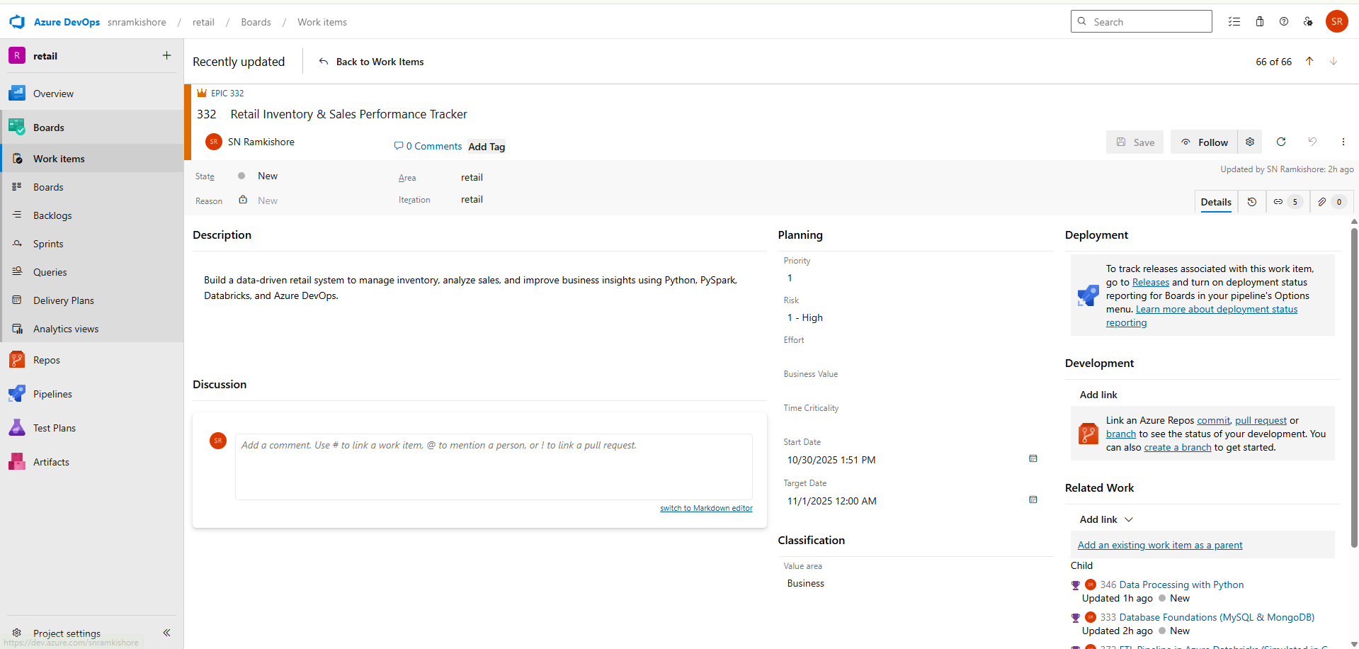

**Feature 1 – Database Foundations (MySQL & MongoDB):**

**Goal:**  
Set up relational and non-relational databases to store and manage retail data efficiently.

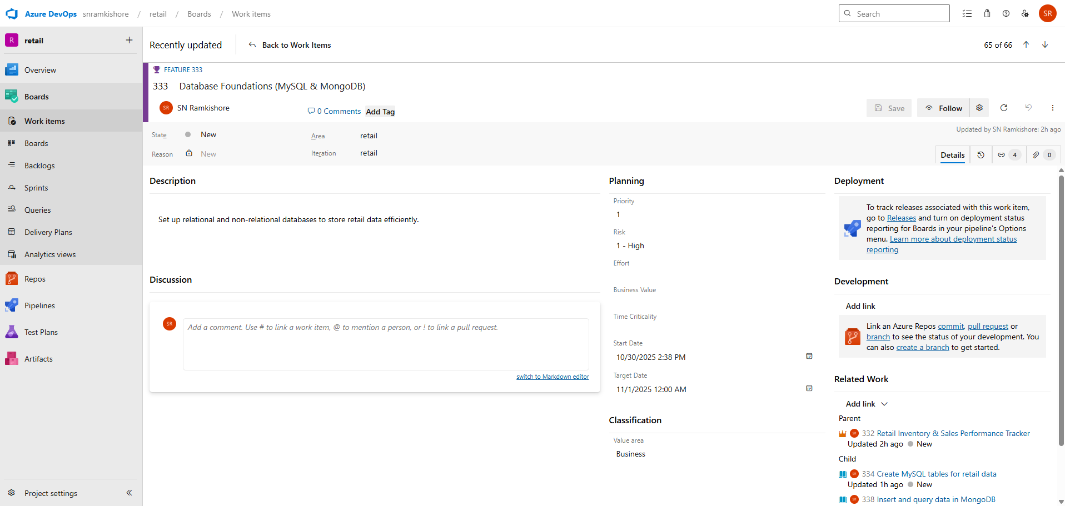

**User Story 1: Create MySQL tables for retail data**

**Description:**  
As a database engineer, I want to design and implement structured MySQL tables for sales, products, and inventory to ensure proper data organization and relationships.

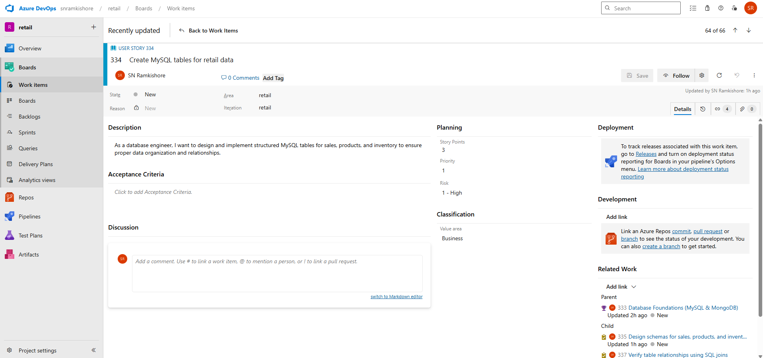

**Tasks:**

1. **Design schemas for sales, products, and inventory tables** – Define primary keys, foreign keys, and data types.

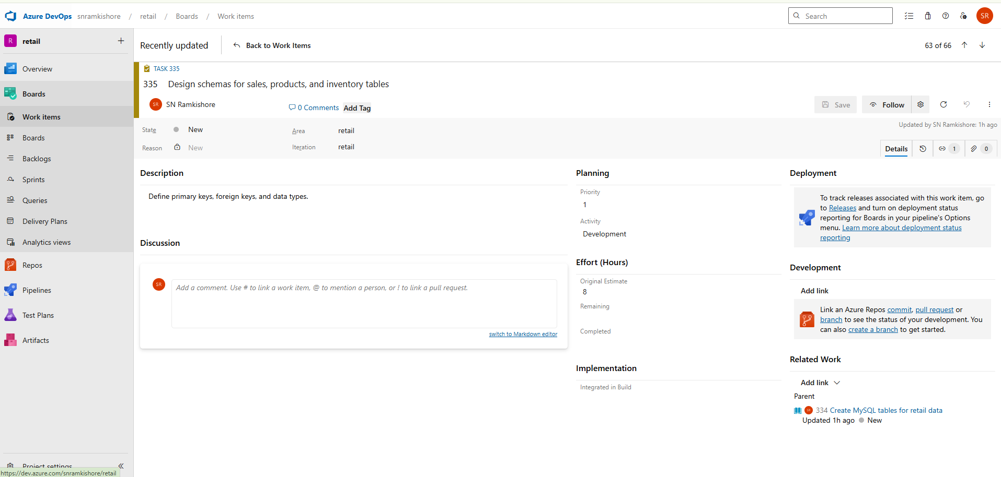

1. **Write SQL scripts to create and populate tables** – Use CREATE and INSERT statements to build initial datasets.

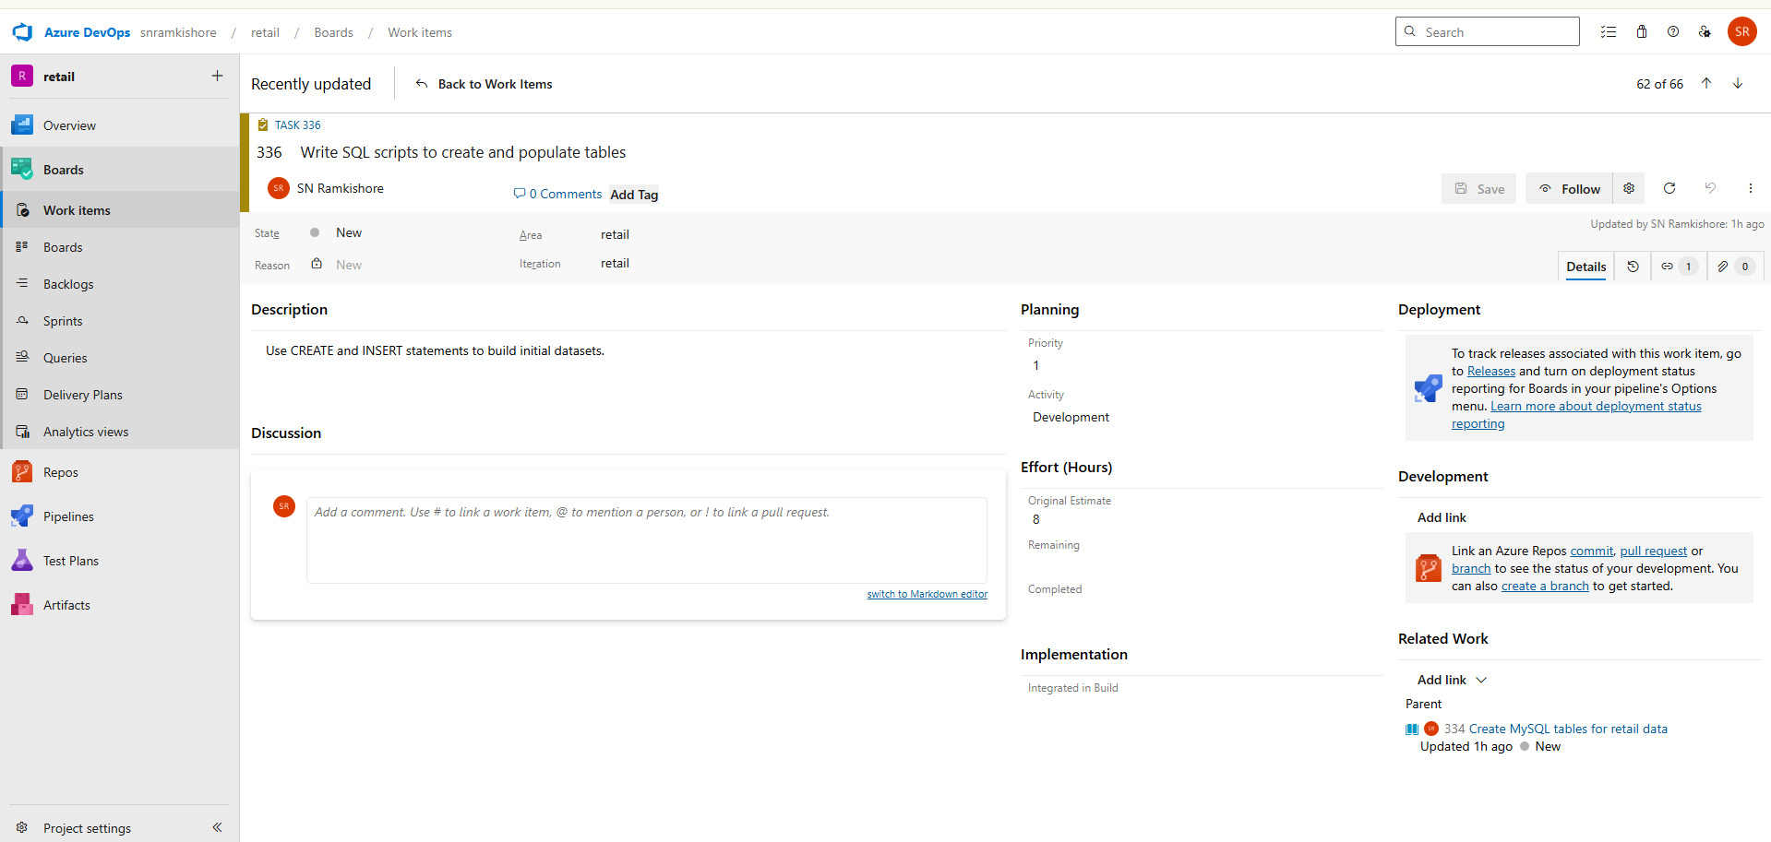

1. **Verify table relationships using SQL joins** – Run INNER and LEFT joins to confirm referential integrity.

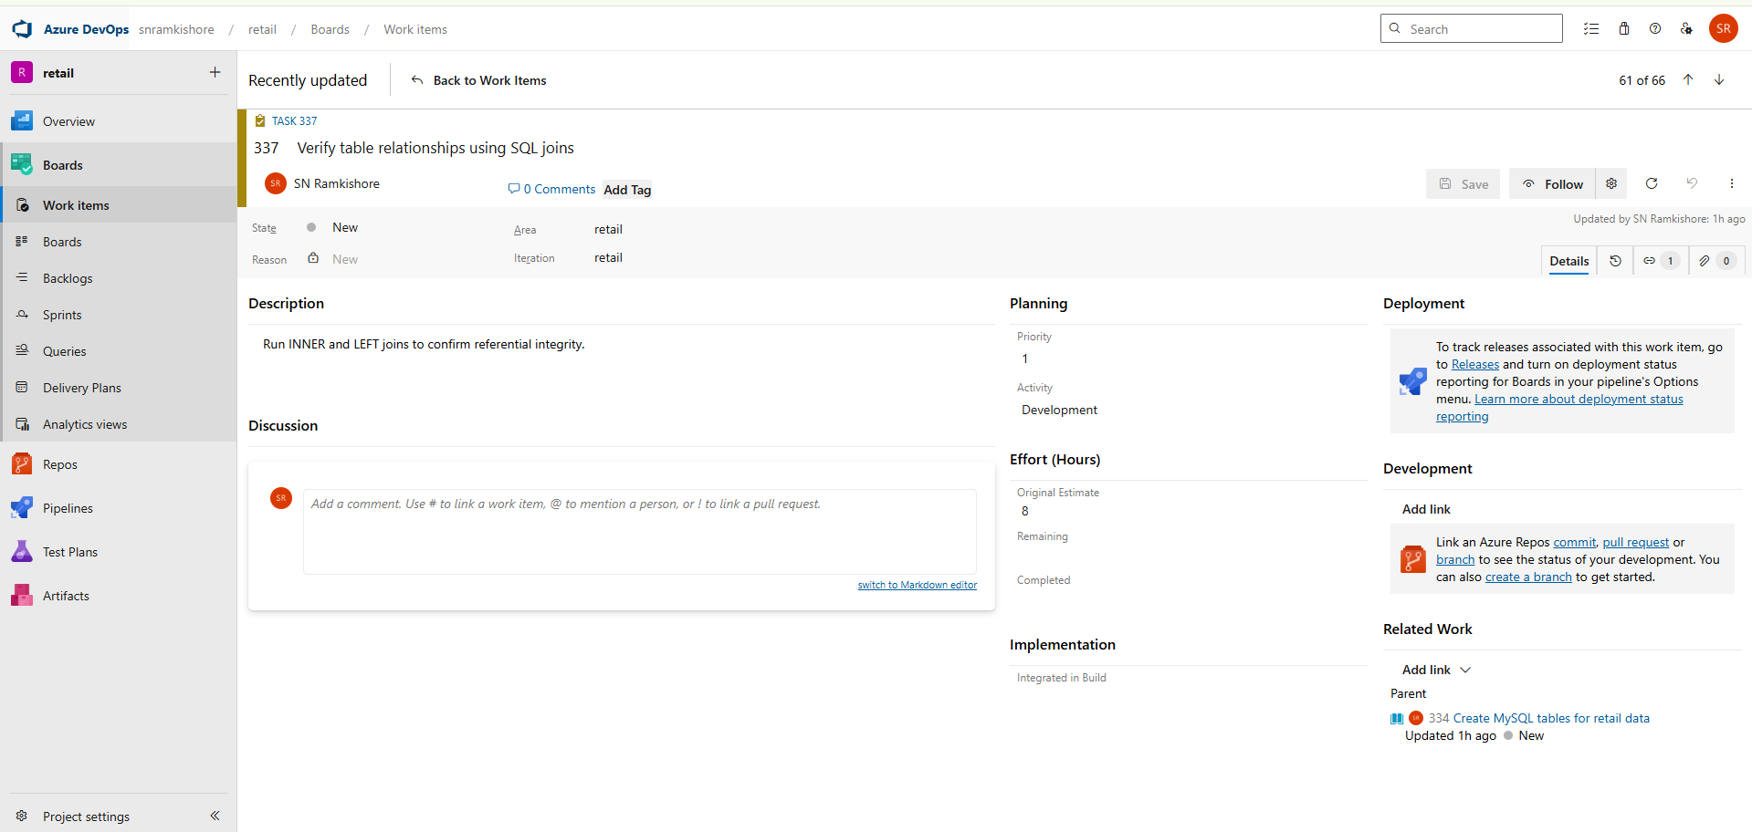

**User Story 2: Insert and query data in MongoDB**

**Description:**  
As a data engineer, I want to store and retrieve unstructured customer feedback using MongoDB collections for better flexibility.

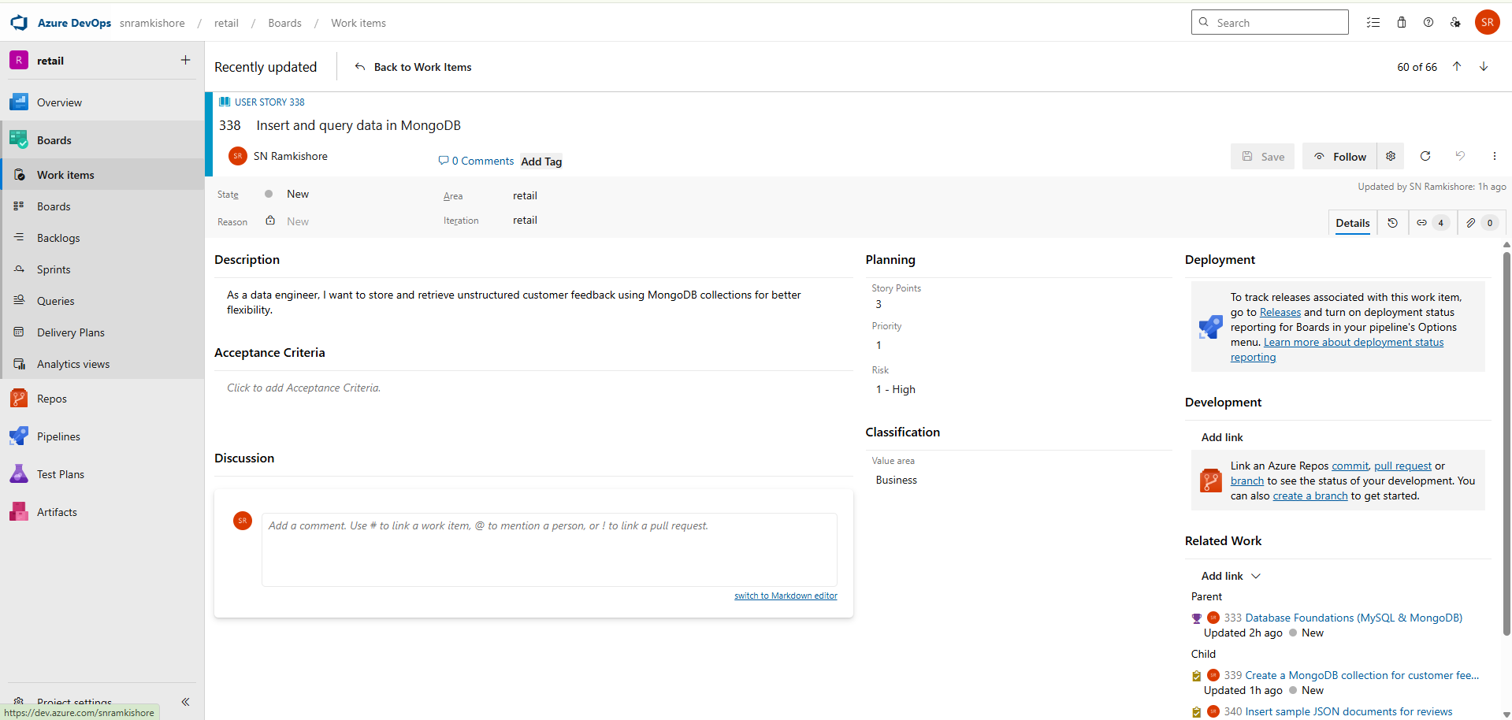

**Tasks:**

1. **Create a MongoDB collection for customer feedback** – Set up a database and define collection names.

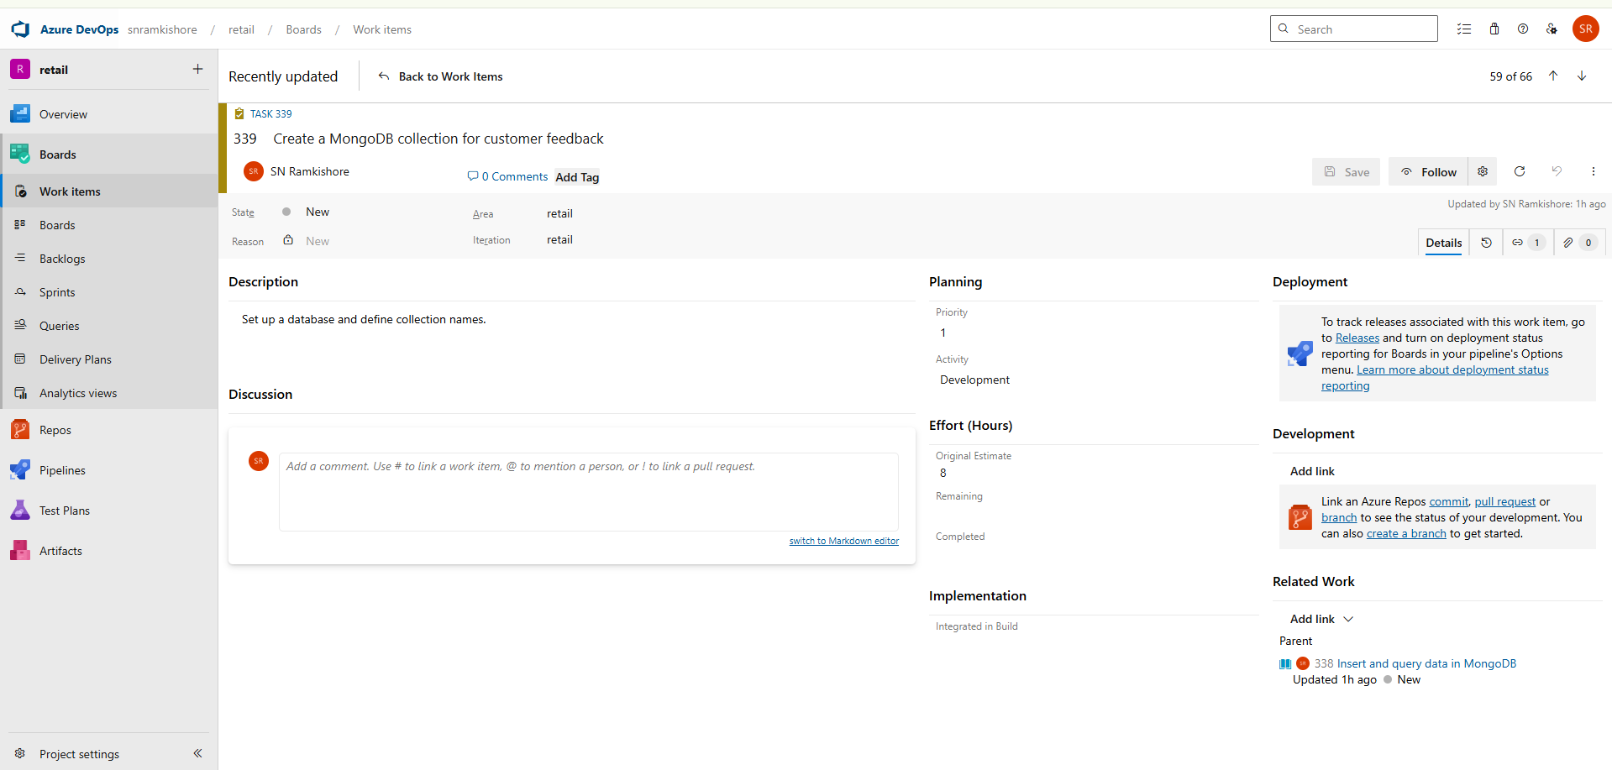

1. **Insert sample JSON documents for reviews** – Populate collections with mock review data.

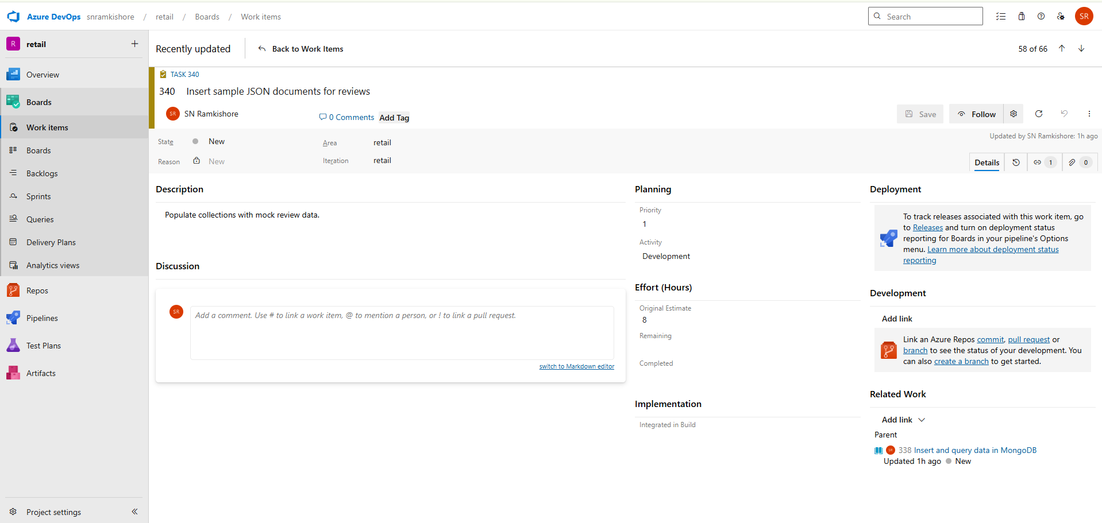

1. **Query and export MongoDB data for analysis** – Use find() queries and export results as JSON or CSV.

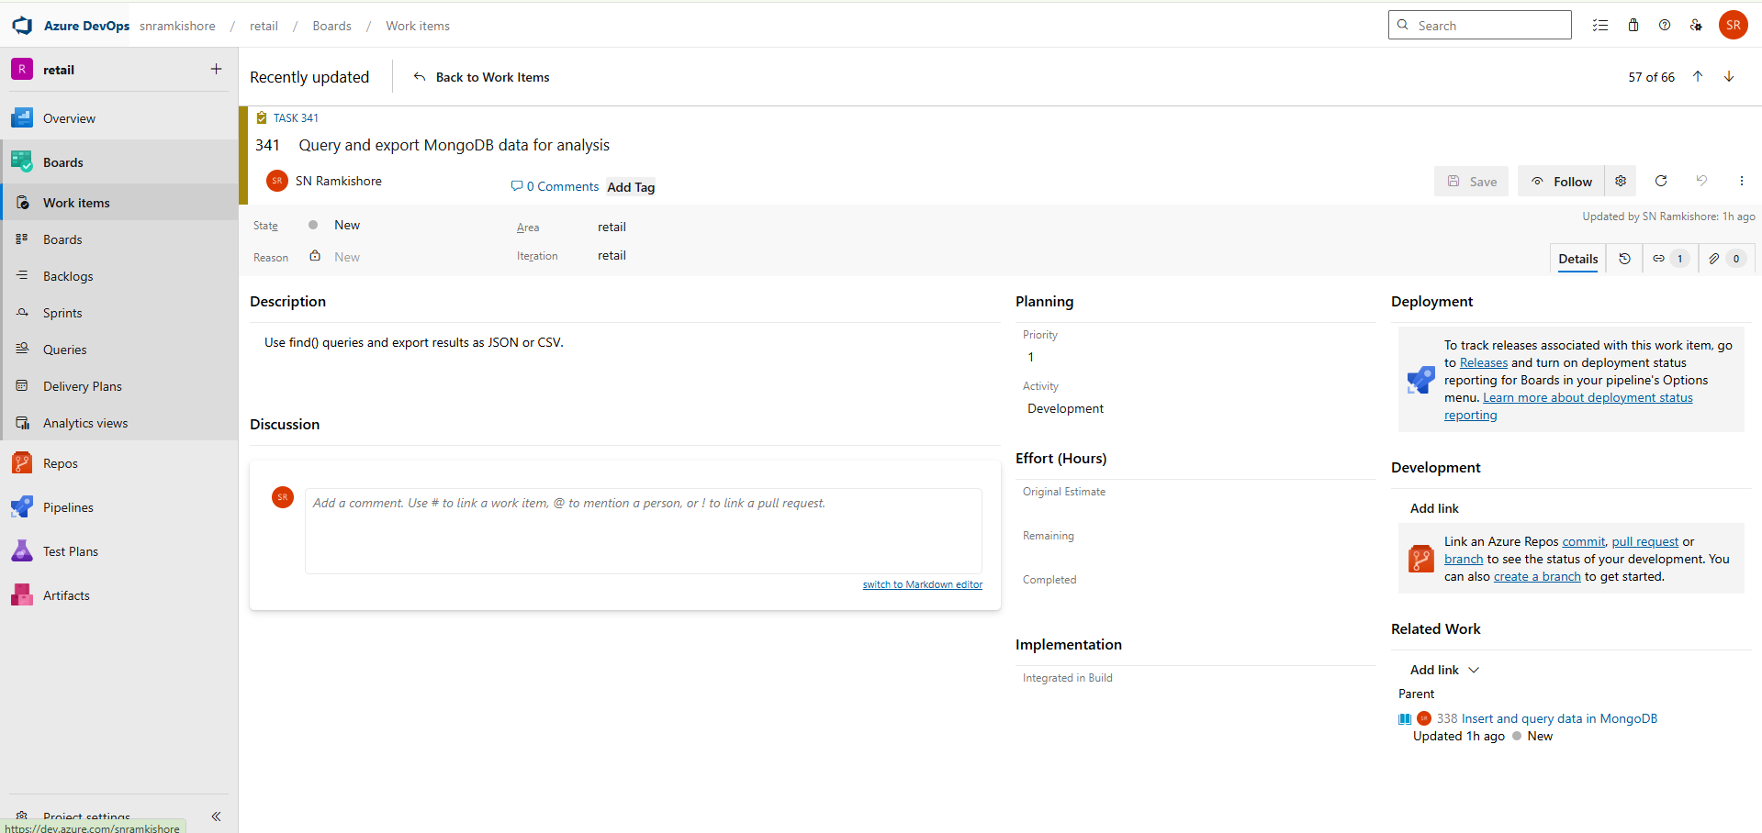

**User Story 3: Retrieve low-stock product data**

**Description:**  
As an analyst, I want to identify products that are below the restocking threshold to ensure timely inventory replenishment.

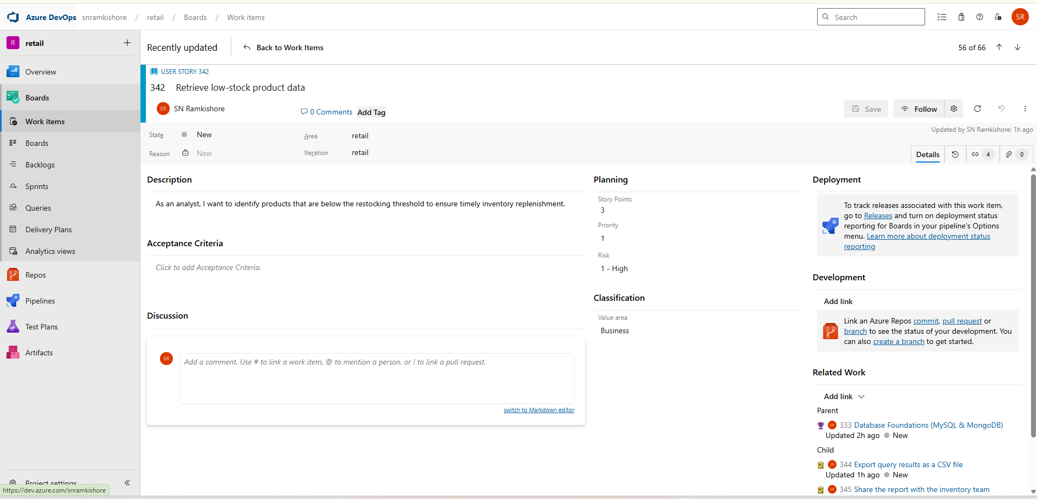

**Tasks:**

1. **Write SQL queries to identify low-stock products** – Filter records where quantity < threshold.

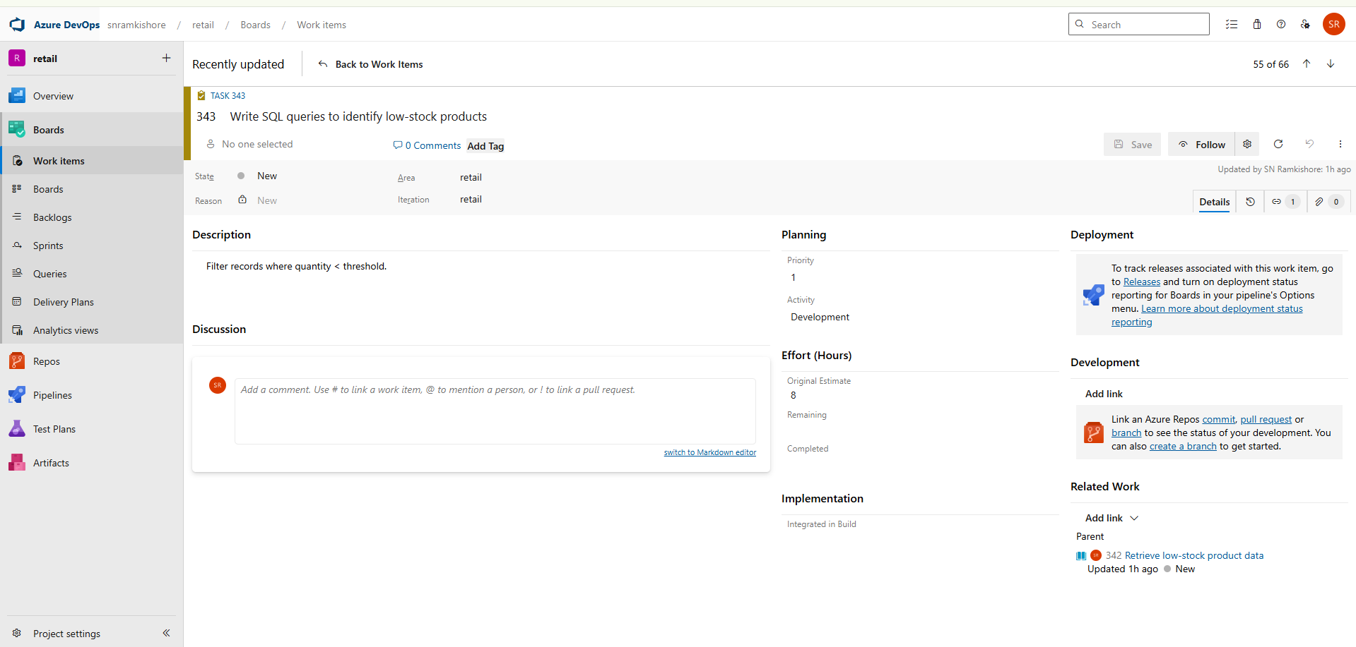

1. **Export query results as a CSV file** – Save results for reporting and review.

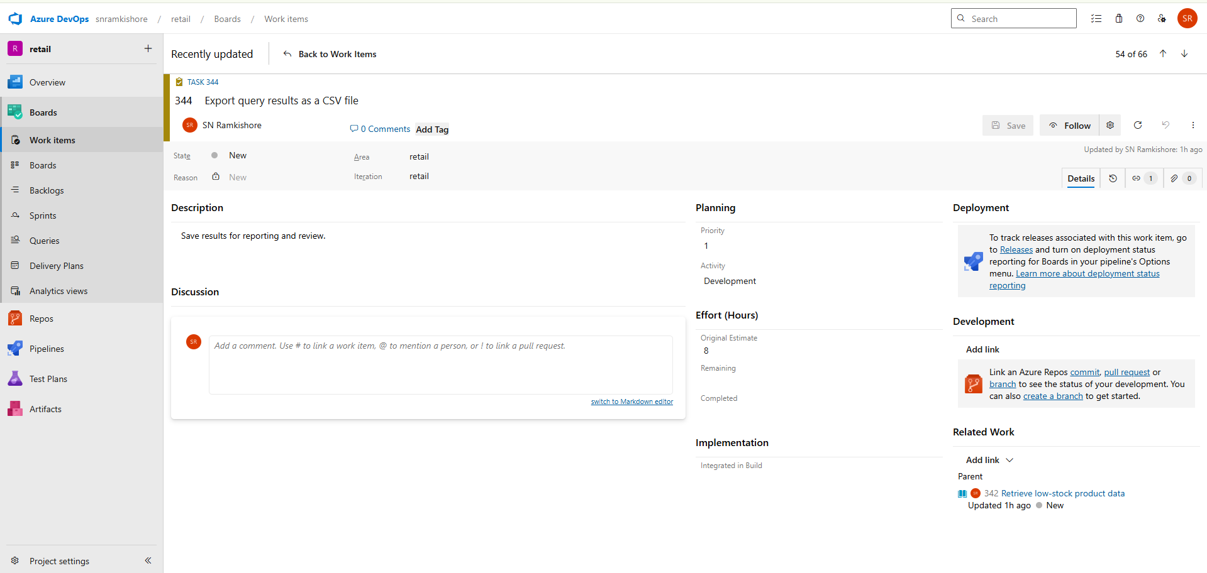

1. **Share the report with the inventory team** – Notify relevant stakeholders for action.

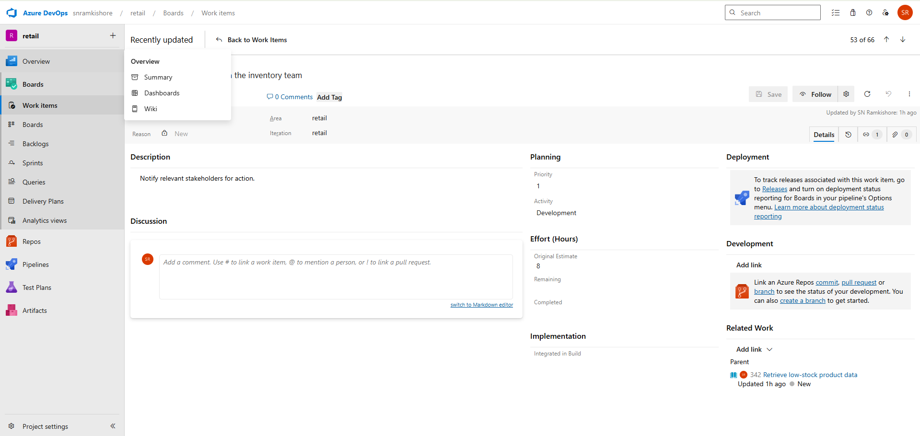

**Feature 2 – Data Processing with Python**

**Goal:**  
Clean, transform, and analyze retail datasets using Pandas and NumPy.

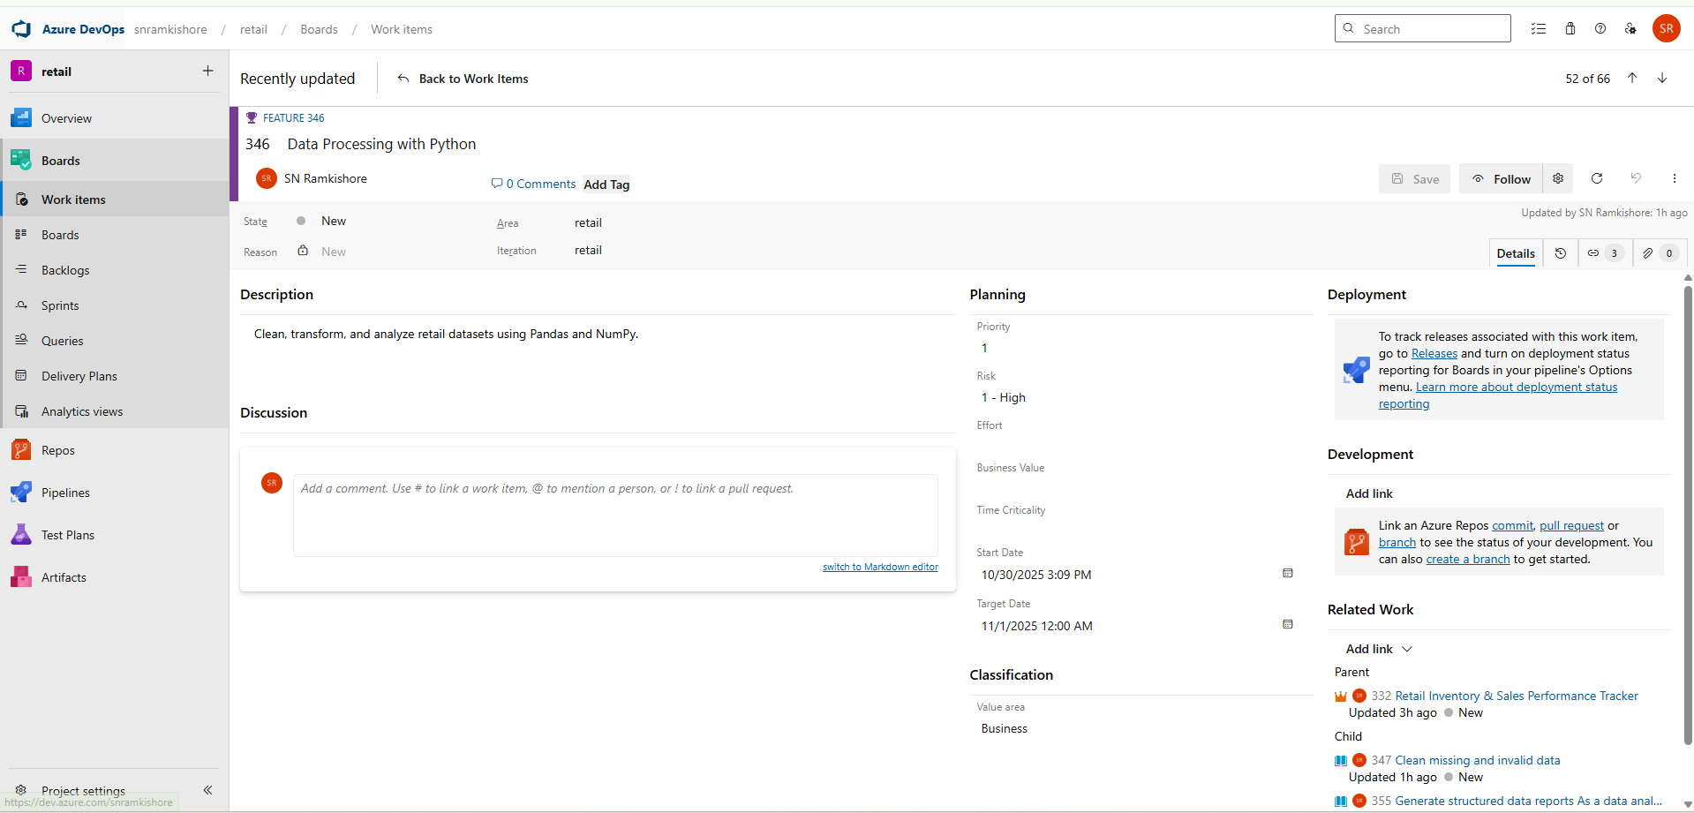

**User Story 1: Clean missing and invalid data**

**Description:**  
As a data engineer, I want to clean missing or invalid values from CSV files to ensure dataset accuracy.

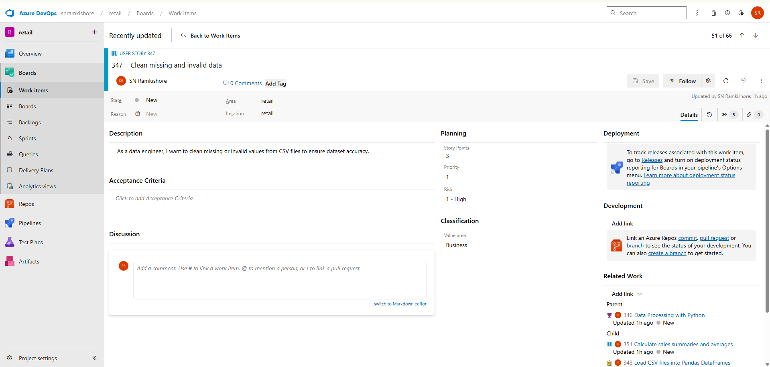

**Tasks:**

1. **Load CSV files into Pandas DataFrames** – Read data from files using pd.read_csv().

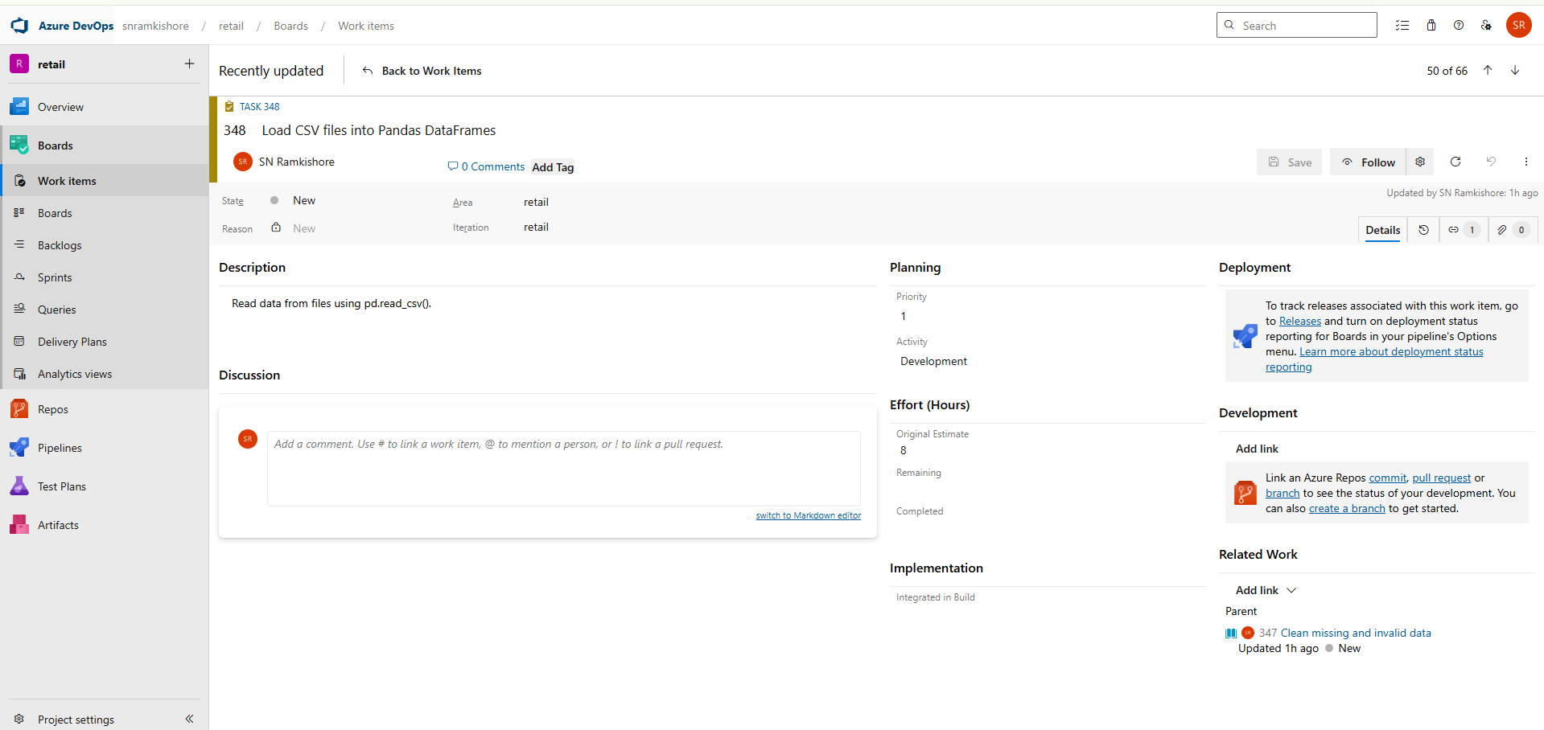

1. **Replace or drop null and invalid values** – Use fillna() or dropna() to clean data.

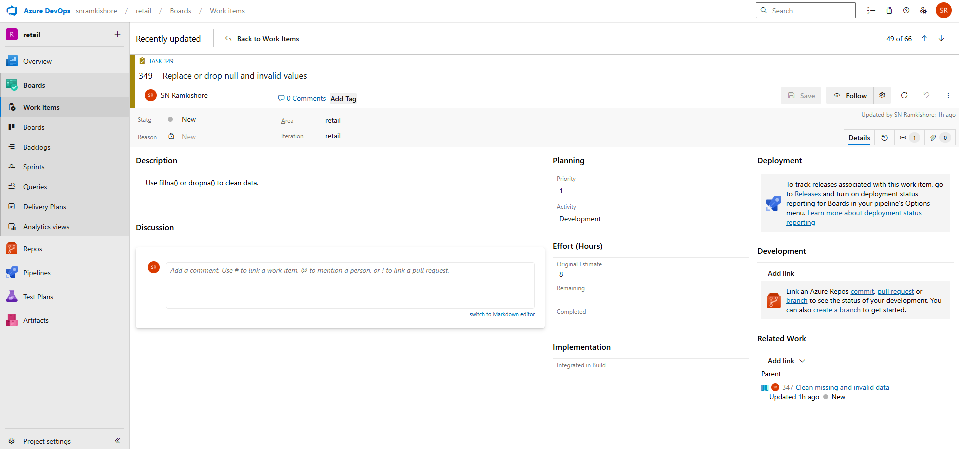

1. **Save the cleaned data as a new CSV** – Store processed files for later ETL steps.

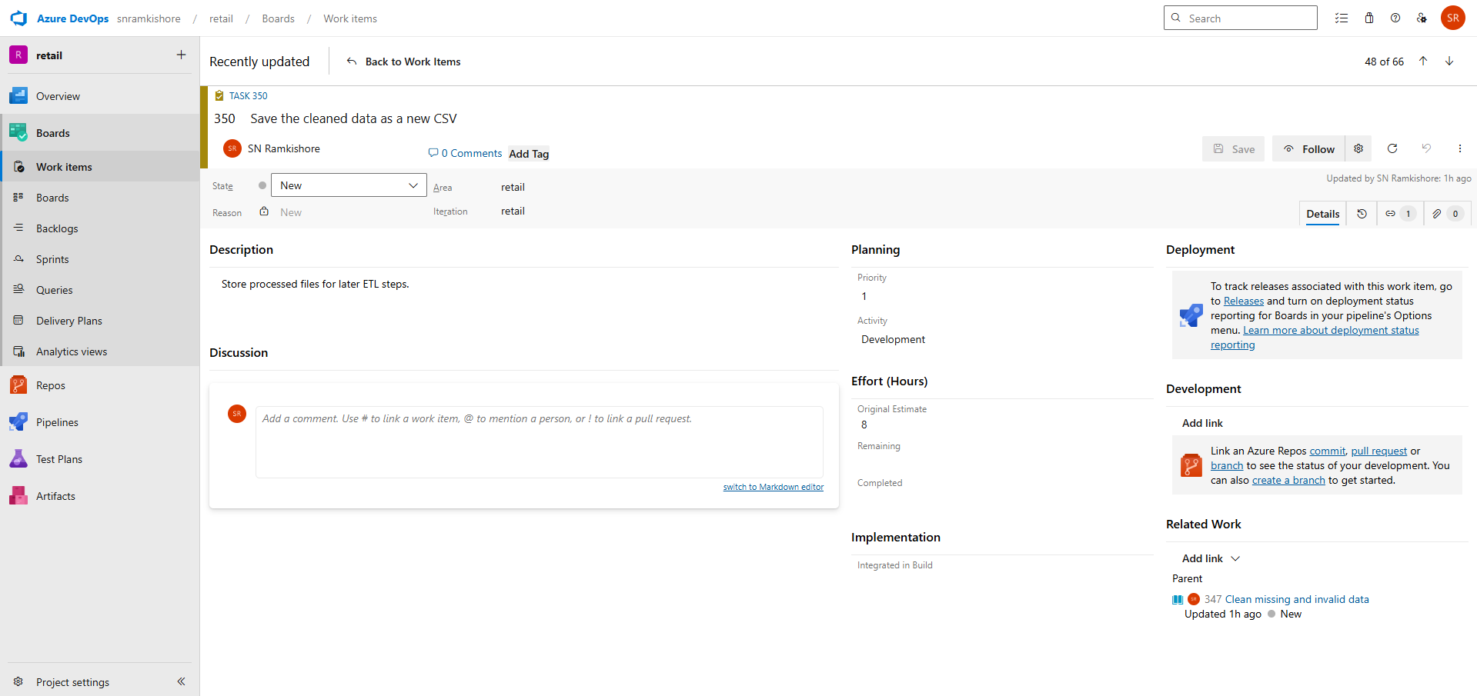

**User Story 2: Calculate sales summaries and averages**

**Description:**  
As a business analyst, I want to calculate total and average sales per product and category to evaluate performance.

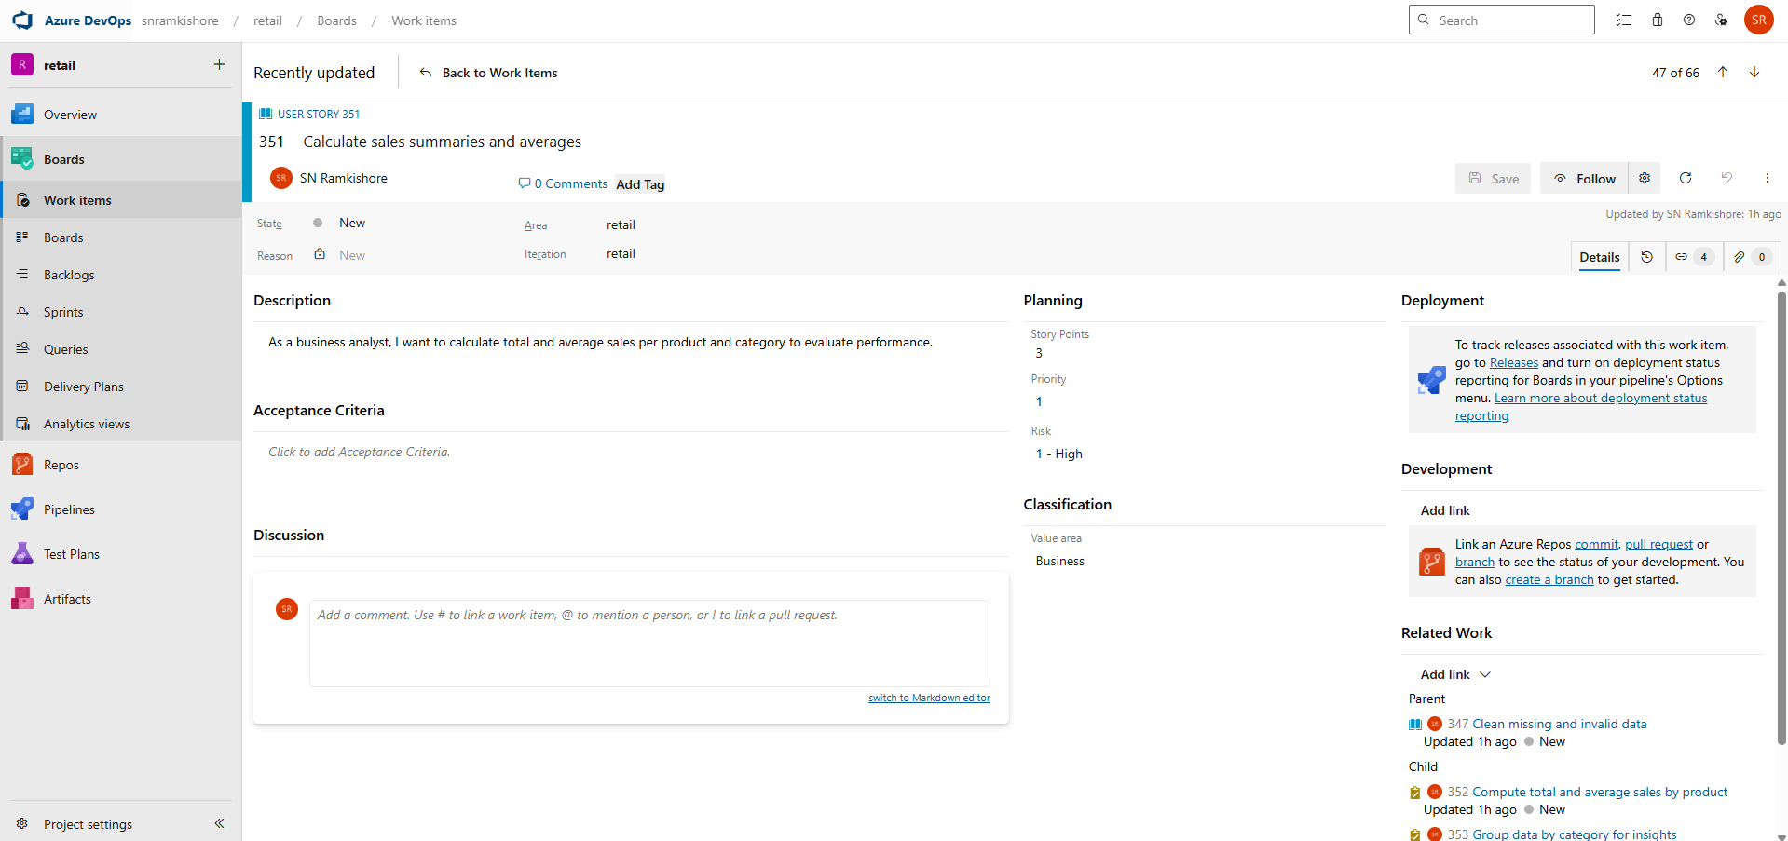

**Tasks:**

1. **Compute total and average sales by product** – Use groupby() and aggregation functions.

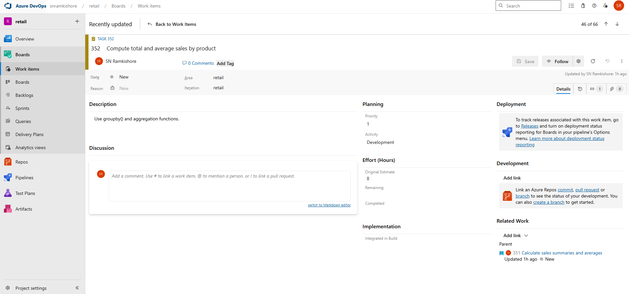

1. **Group data by category for insights** – Summarize sales performance by category.

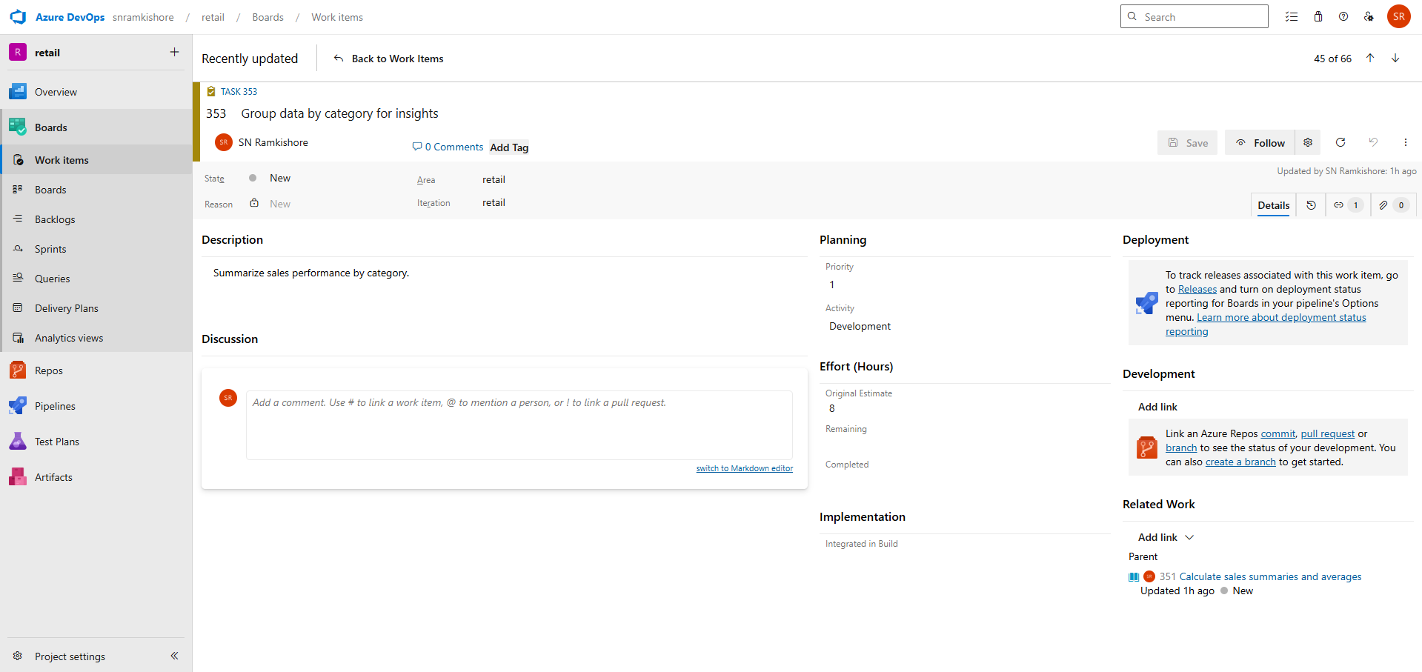

1. **Visualize results using Matplotlib or Seaborn** – Create charts for presentation.

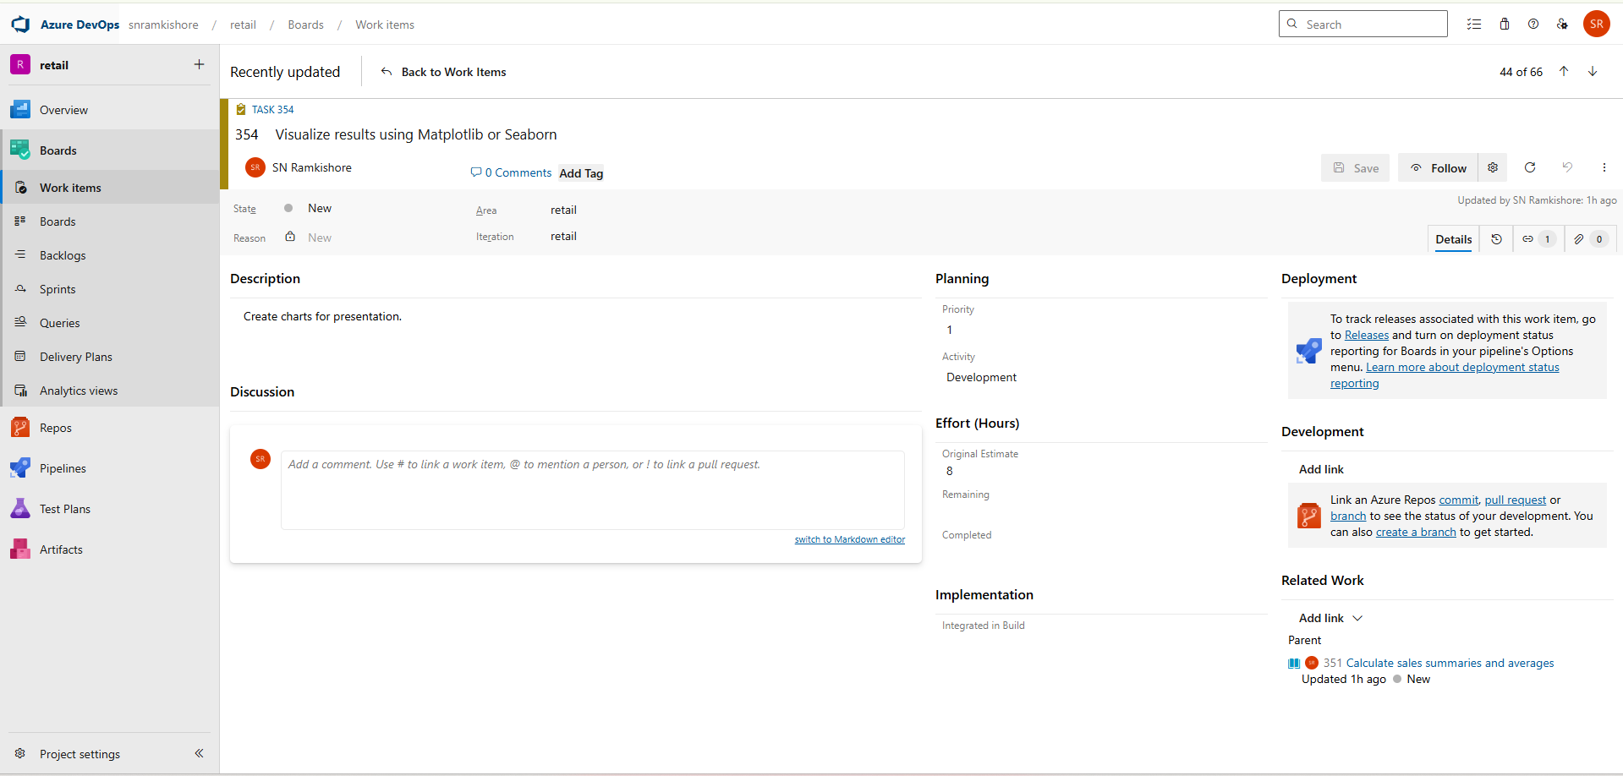

**User Story 3: Generate structured data reports**

**Description:**  
As a data analyst, I want to generate formatted summary reports for stakeholders to review trends.

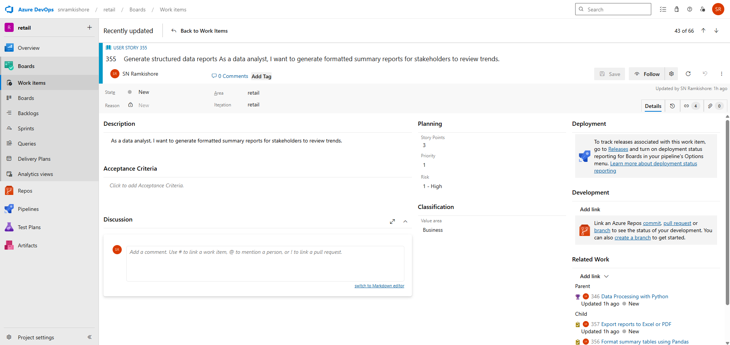

**Tasks:**

1. **Format summary tables using Pandas** – Adjust column names, order, and precision.

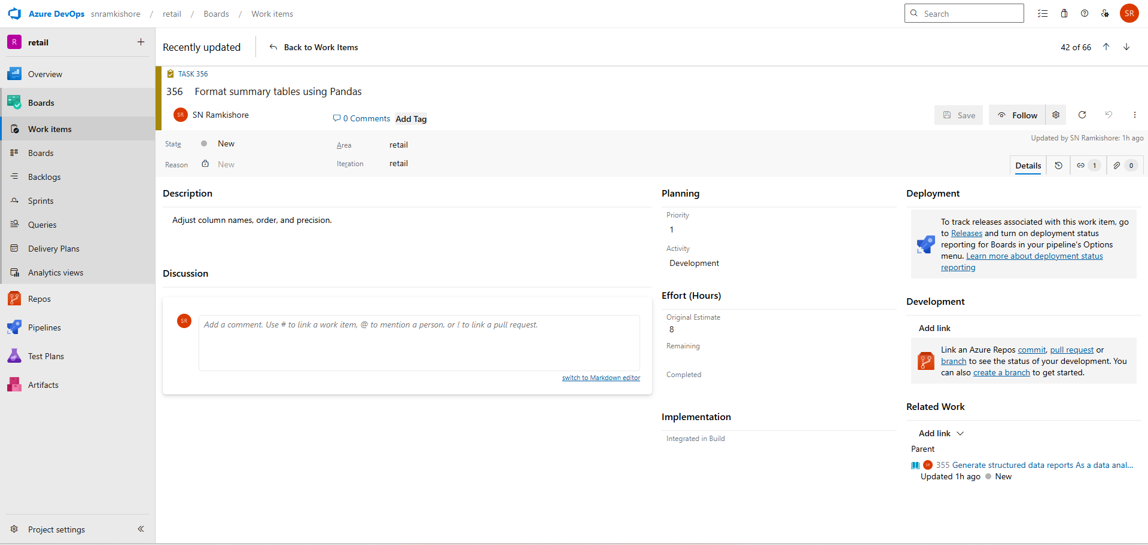

1. **Export reports to Excel or PDF** – Save outputs using to_excel() or reportlab.

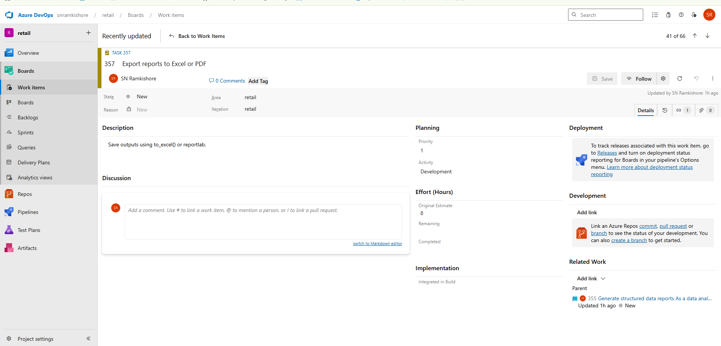

1. **Share output with stakeholders** – Distribute files via email or shared drive.

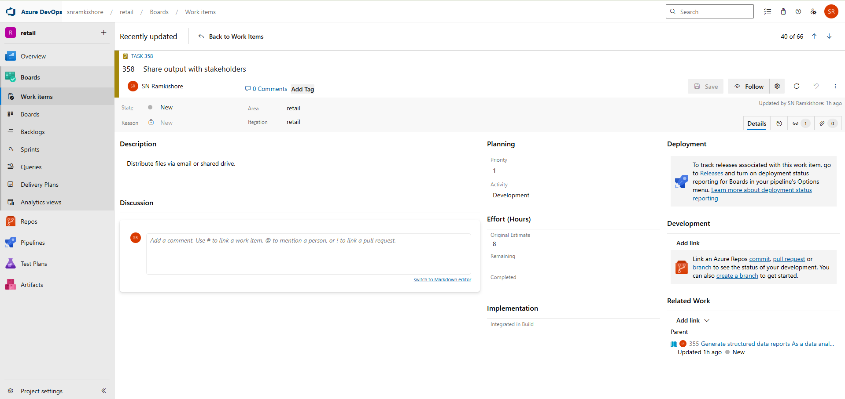

**Feature 3 – Retail Insights with PySpark**

**Goal:**  
Leverage PySpark to handle large-scale data processing and analysis efficiently.

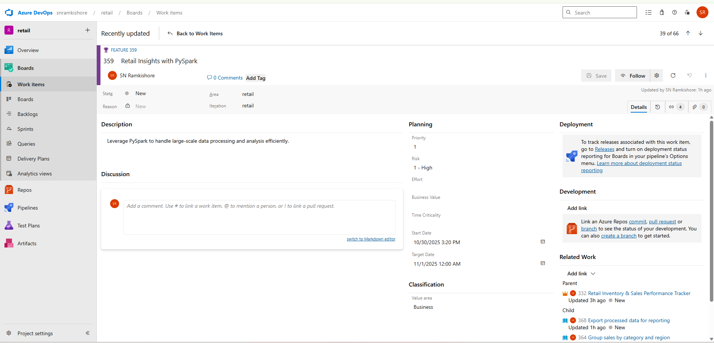

**User Story 1: Load large datasets using PySpark**

**Description:**  
As a data engineer, I want to load large CSVs into Spark DataFrames for scalable processing.

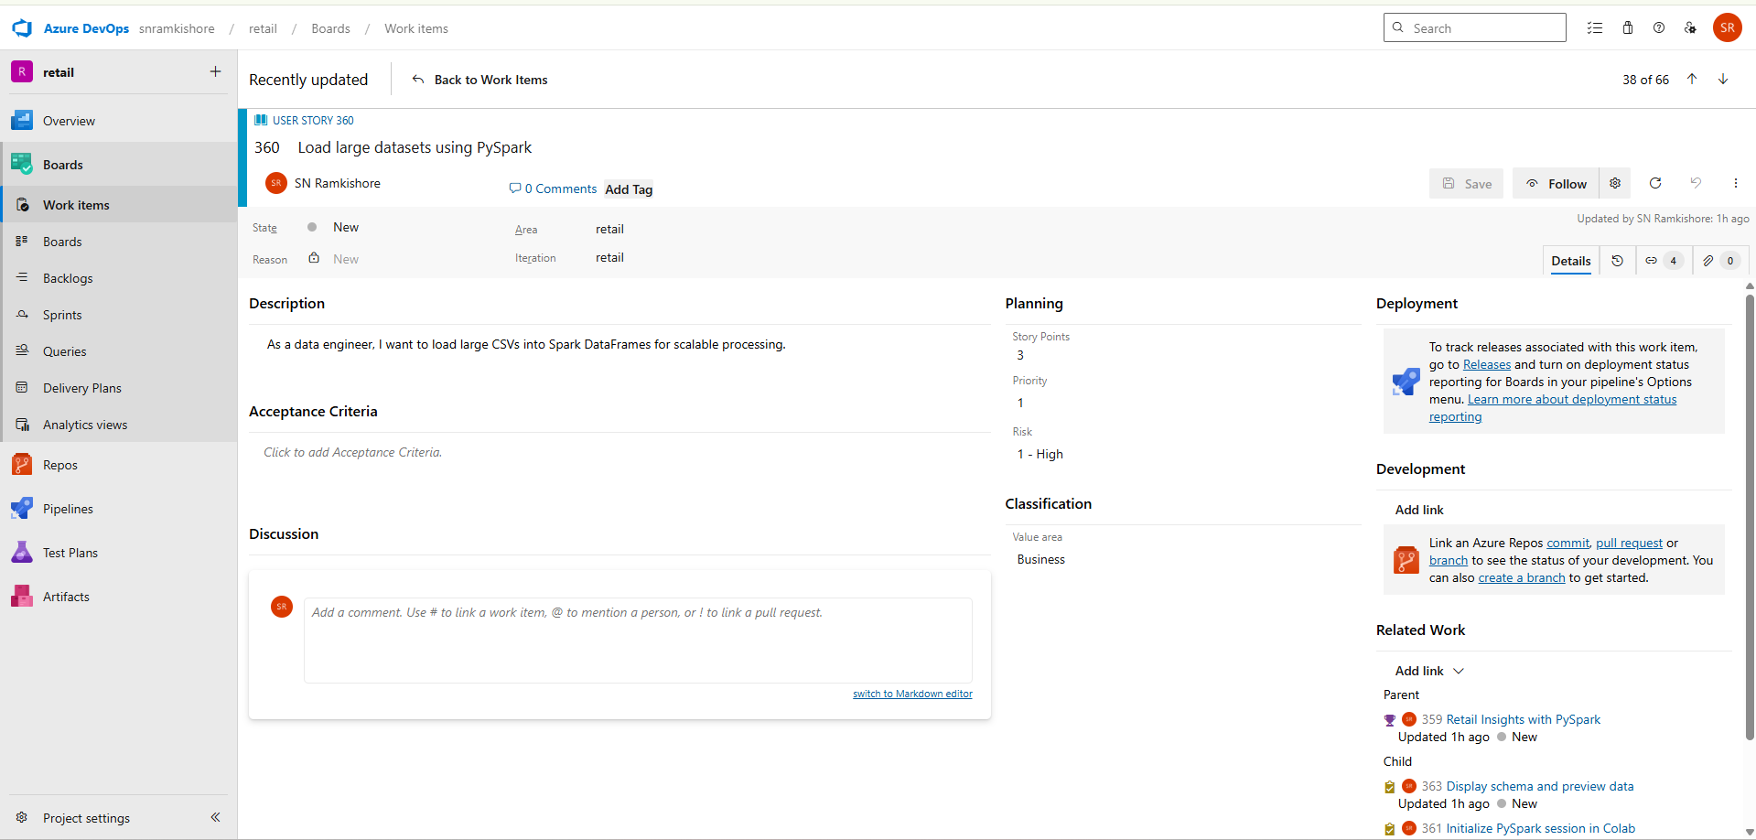

**Tasks:**

1. **Initialize PySpark session in Colab** – Set up SparkSession using SparkSession.builder.

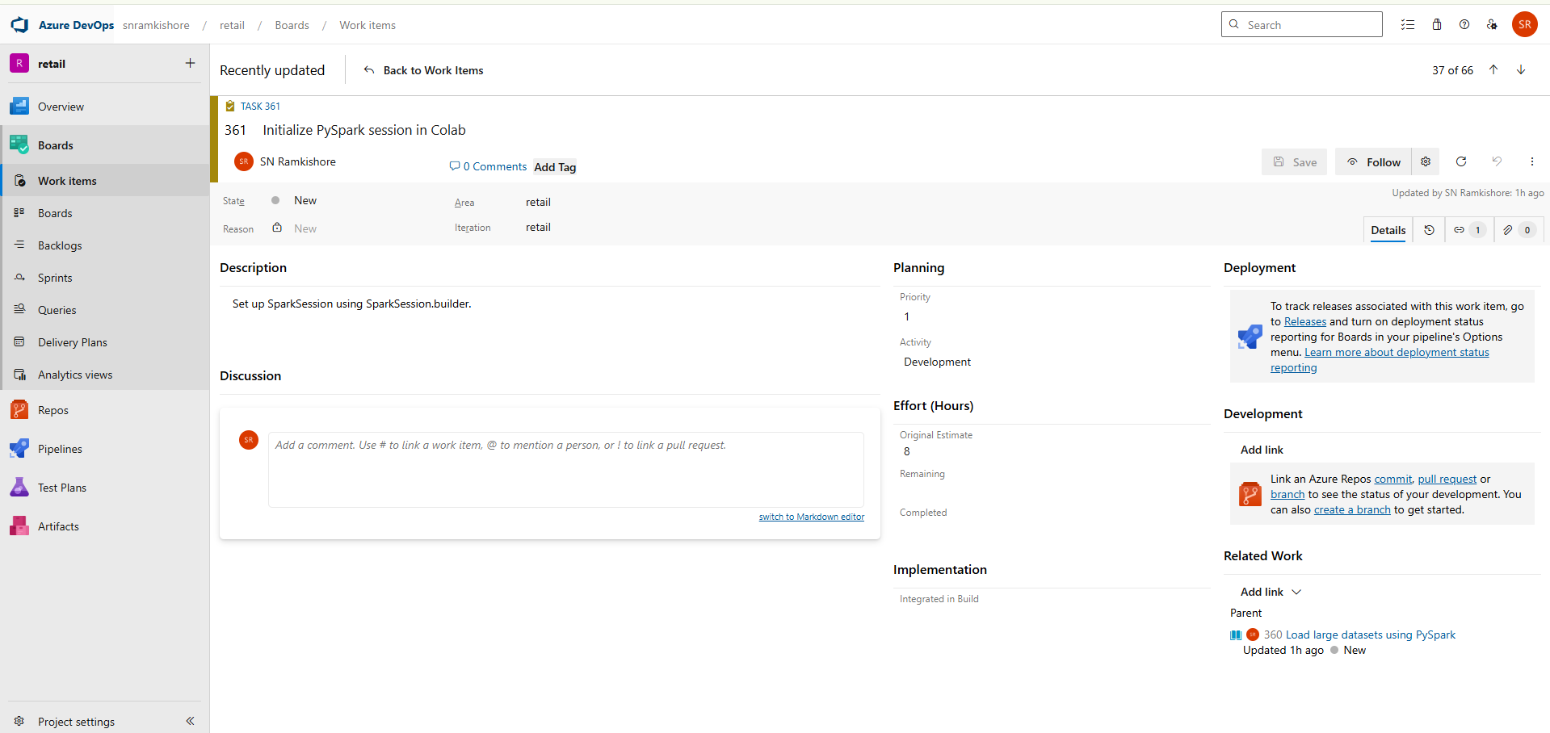

1. **Read sales and inventory data** – Use spark.read.csv() to import data.

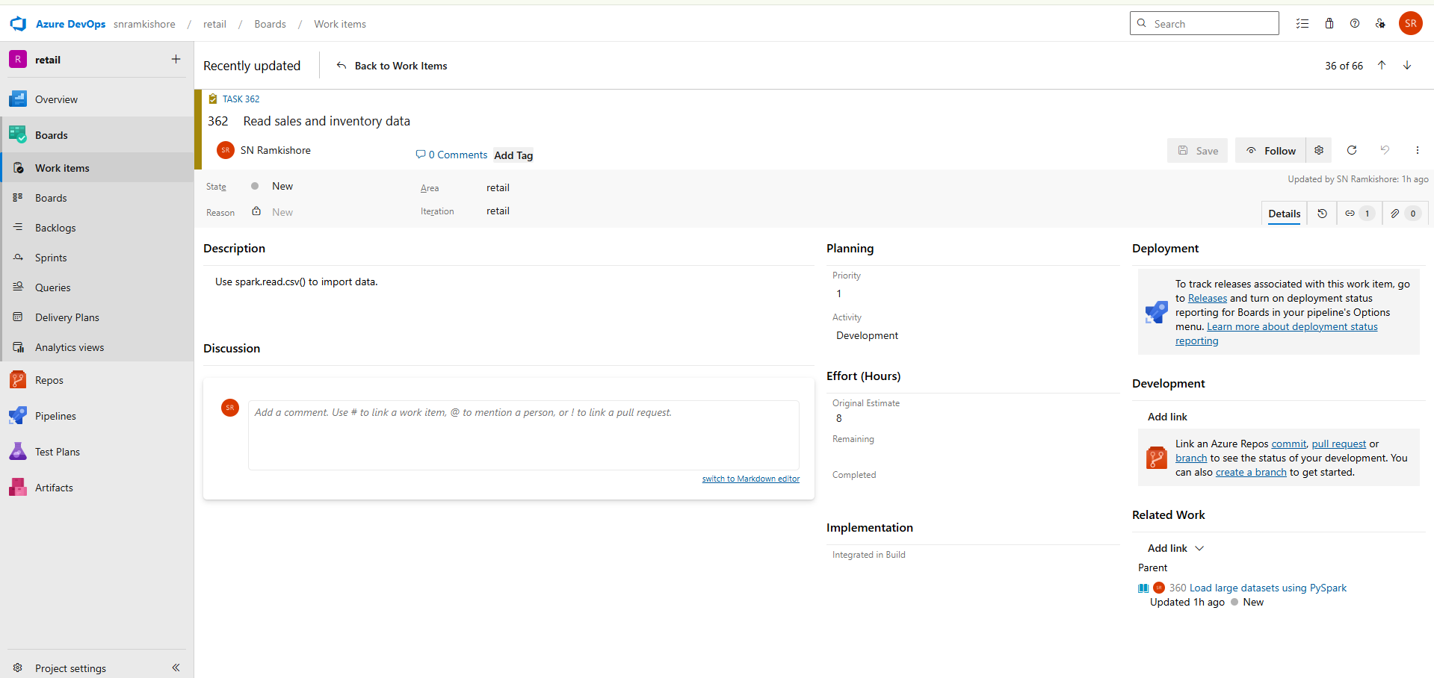

1. **Display schema and preview data** – Validate data structure with df.printSchema().

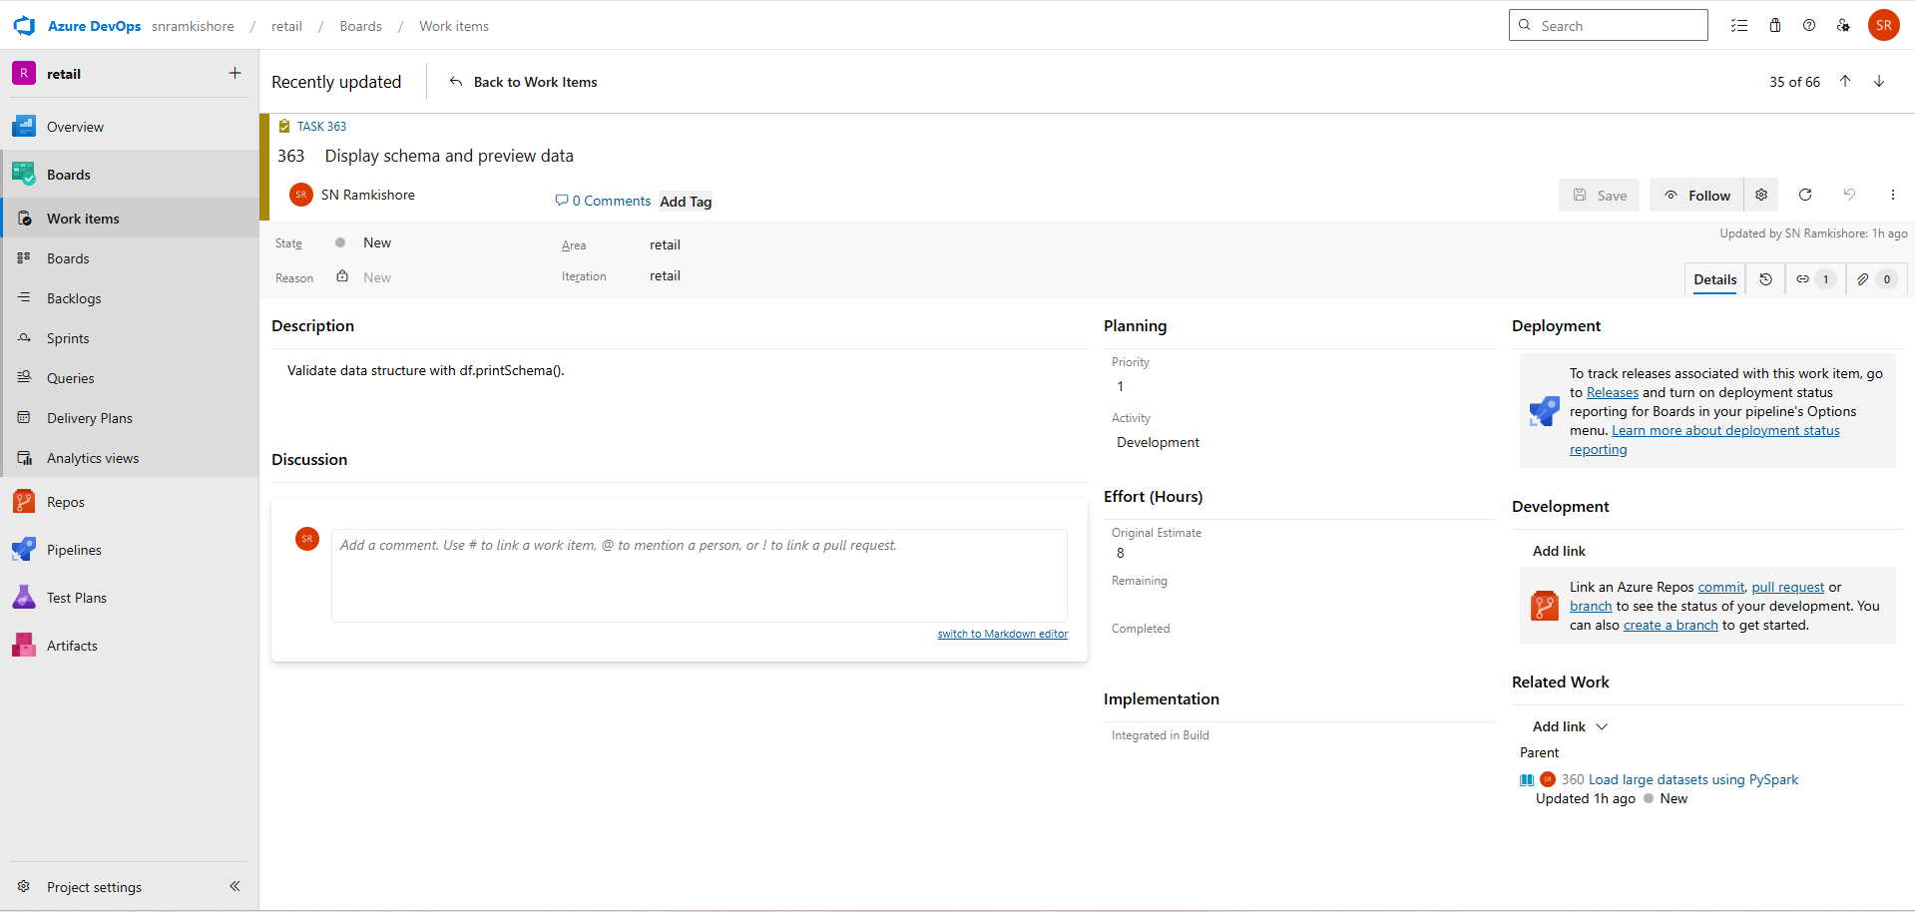

**User Story 2: Group sales by category and region**

**Description:**  
As an analyst, I want to aggregate sales by category and region to find top-performing areas.

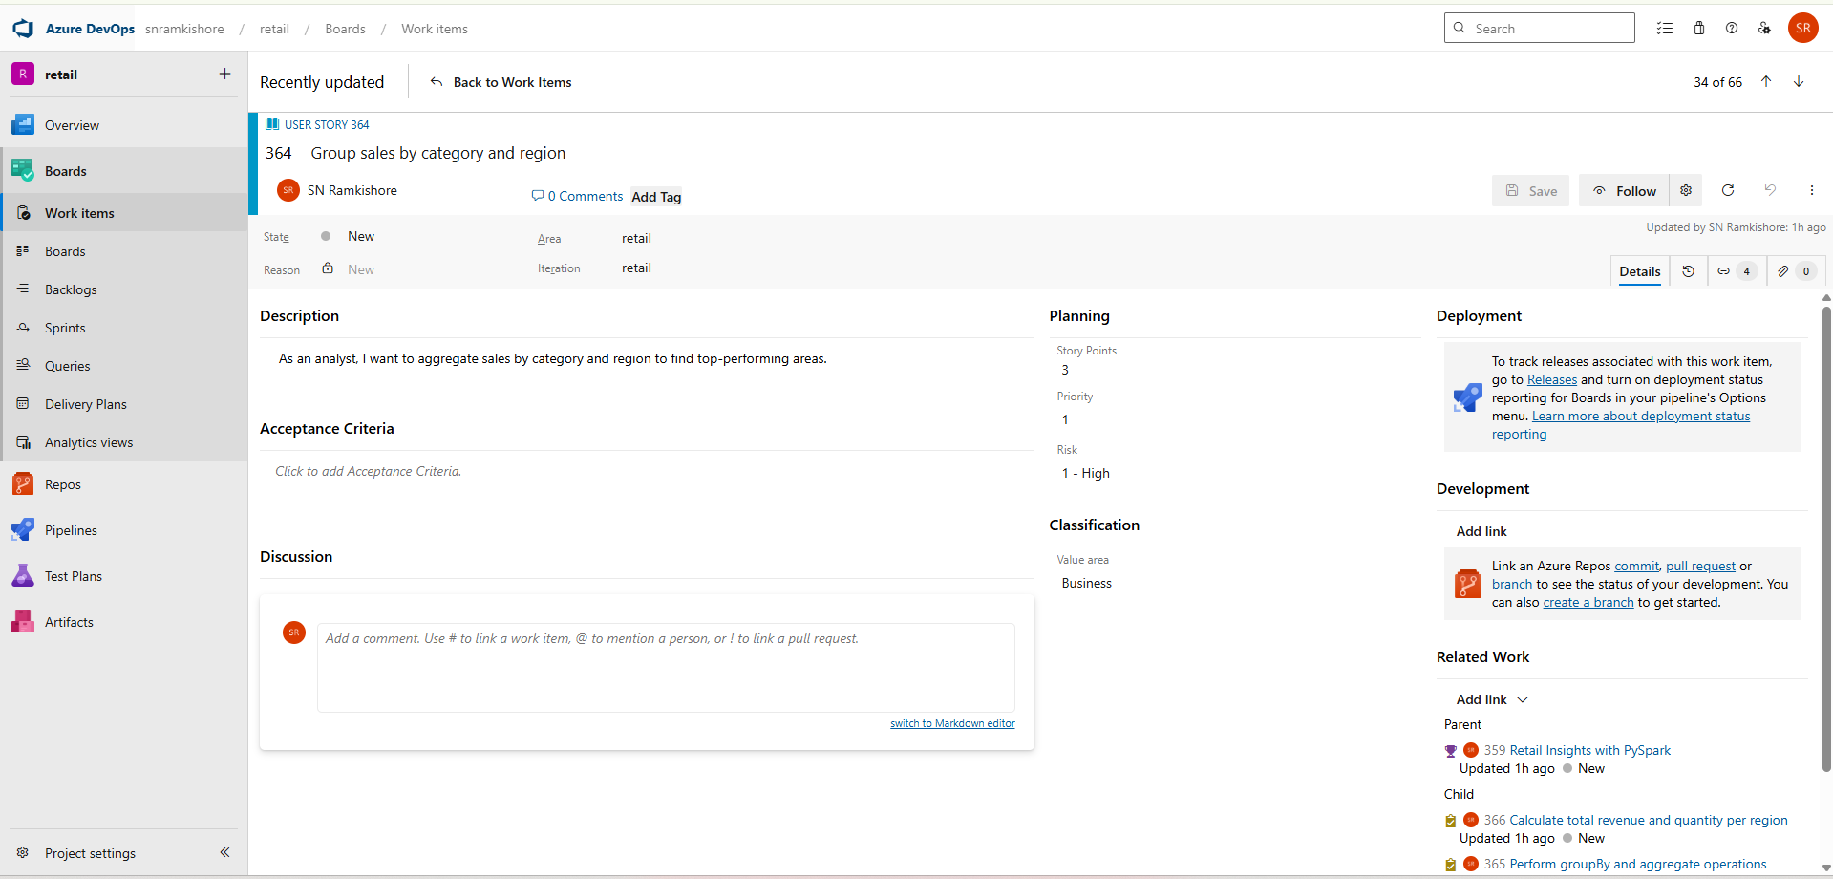

**Tasks:**

1. **Perform groupBy and aggregate operations** – Use groupBy().agg() for metrics.

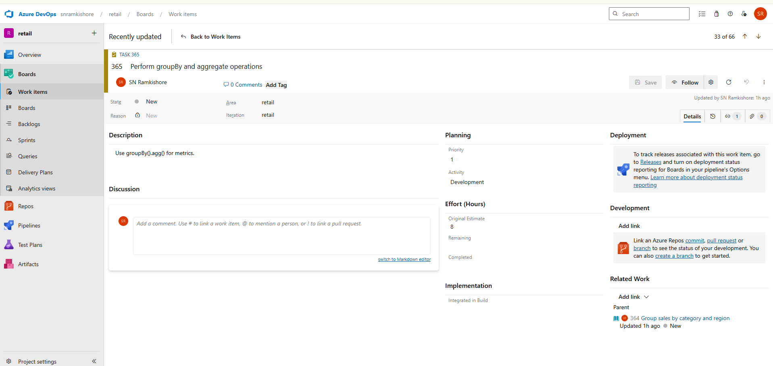

1. **Calculate total revenue and quantity per region** – Sum relevant fields.

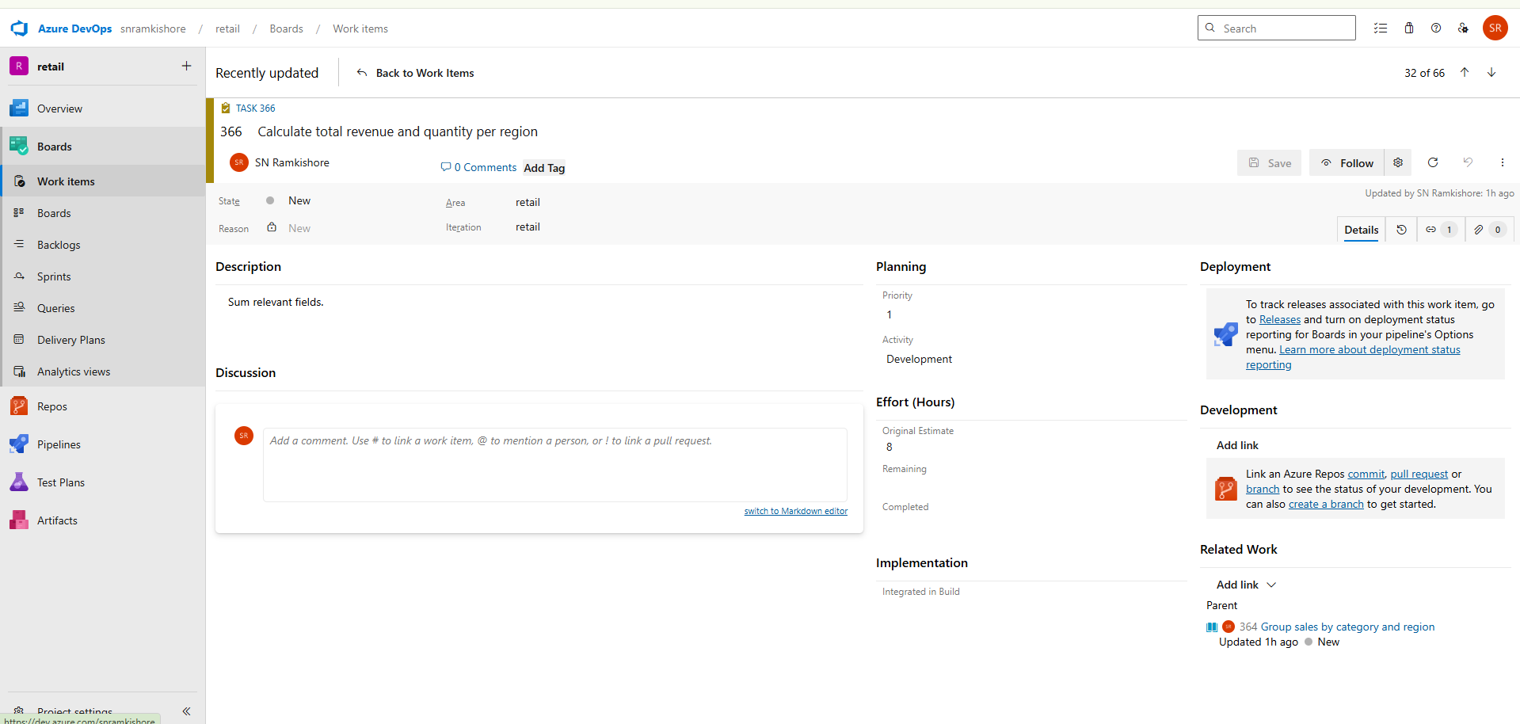

1. **Save aggregated results as Parquet** – Store results efficiently for reporting.

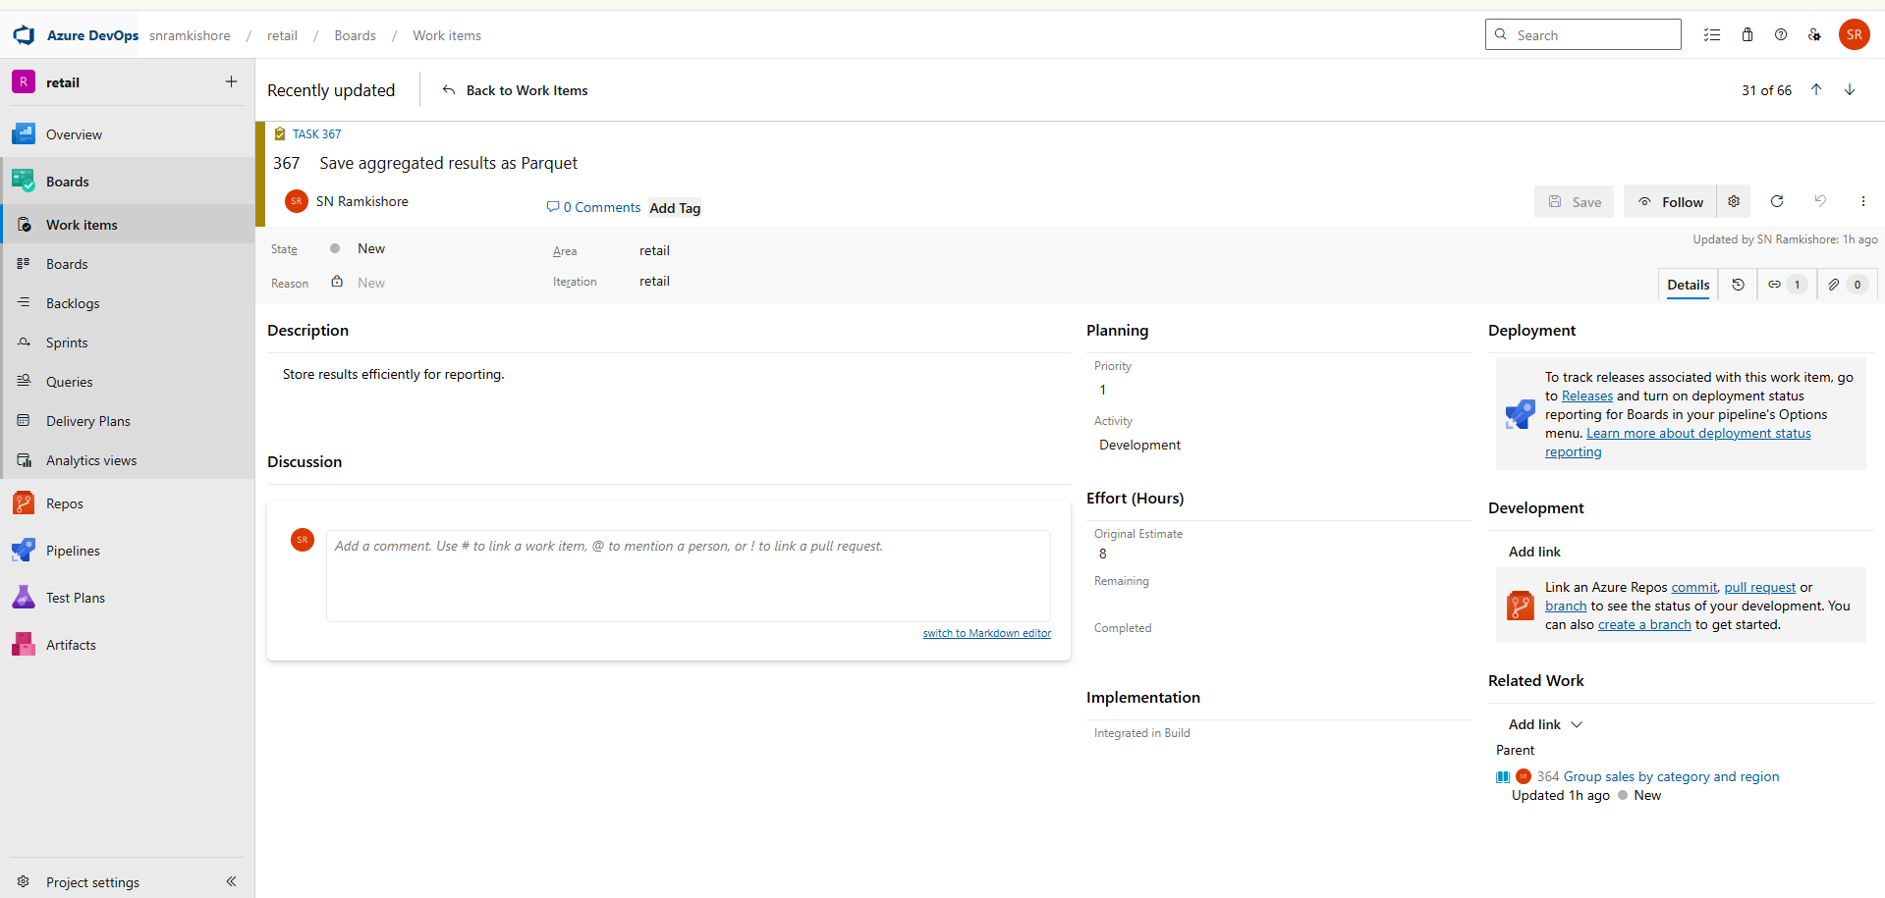

**User Story 3: Export processed data for reporting**

**Description:**  
As a data specialist, I want to export transformed Spark DataFrames for visualization.

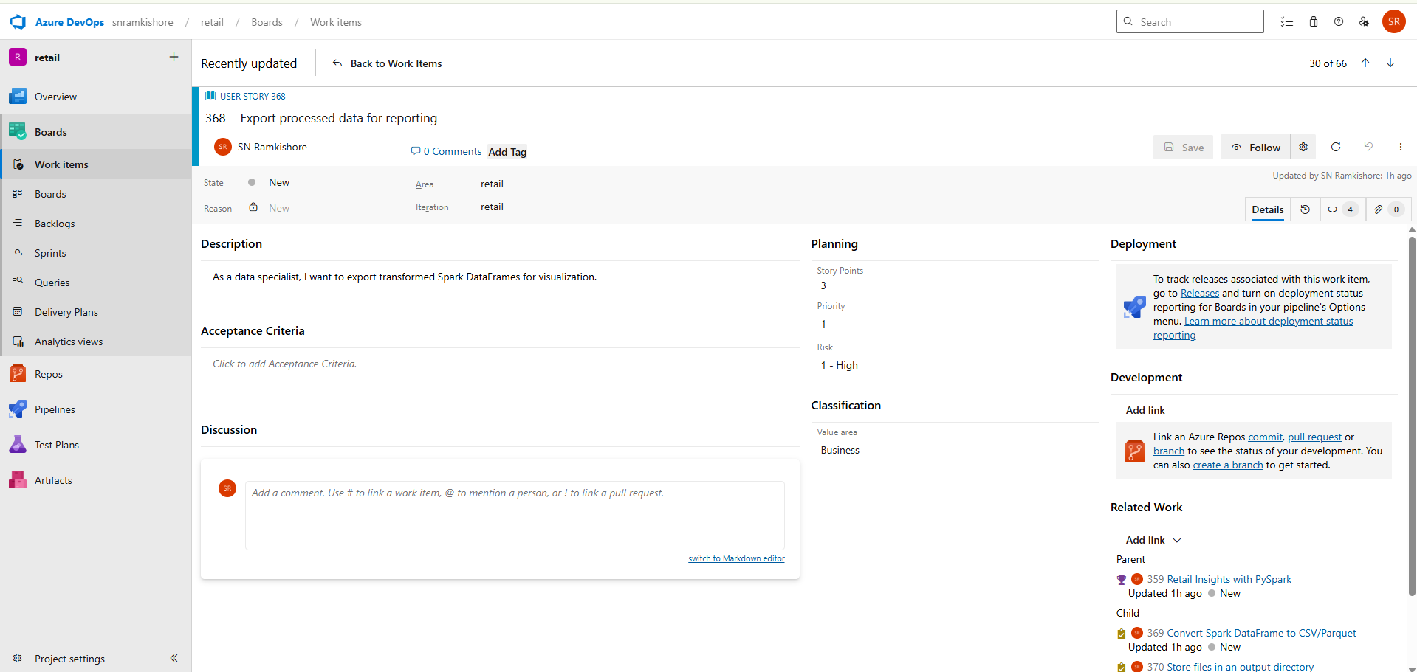

**Tasks:**

1. **Convert Spark DataFrame to CSV/Parquet** – Use df.write.csv() or .parquet().

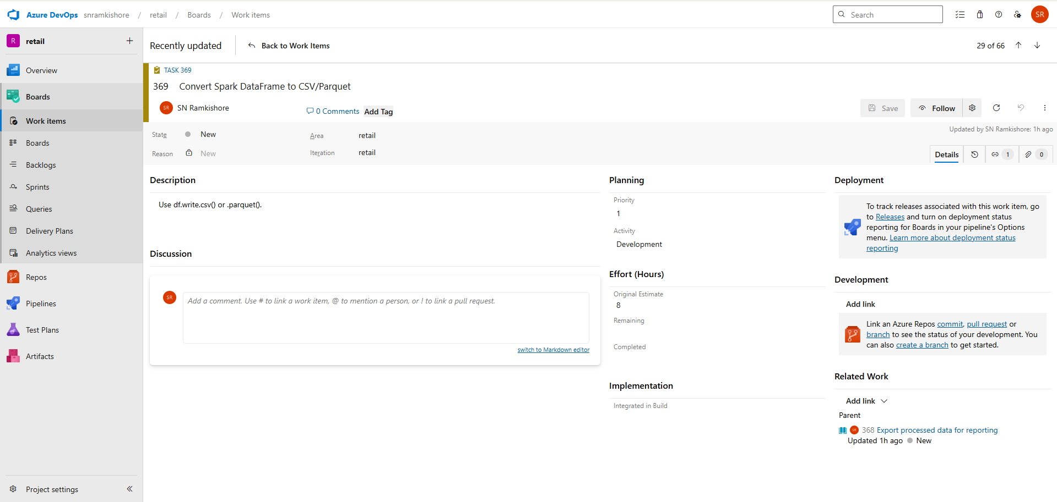

1. **Store files in an output directory** – Ensure folder hierarchy is consistent.

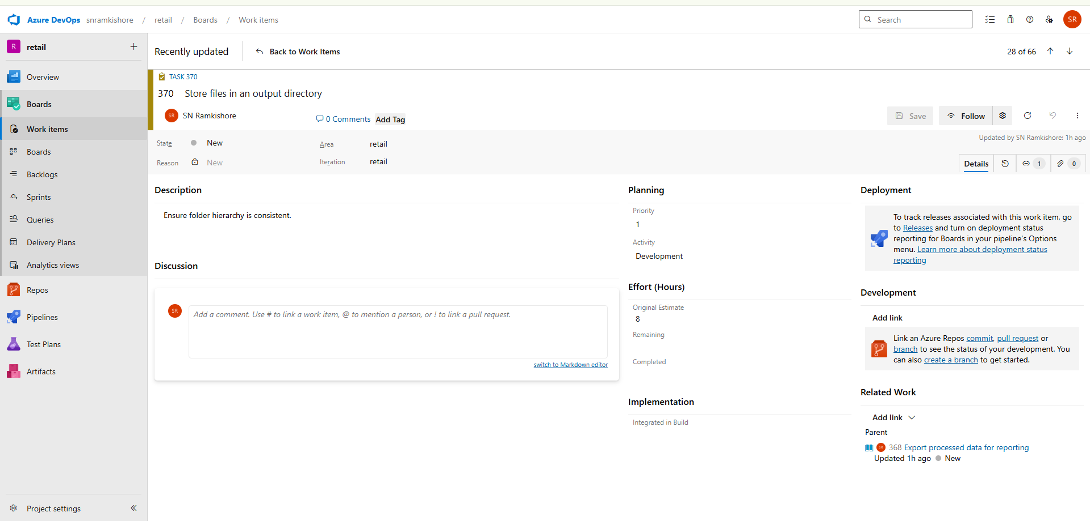

1. **Validate data using df.describe()** – Check accuracy before distribution.

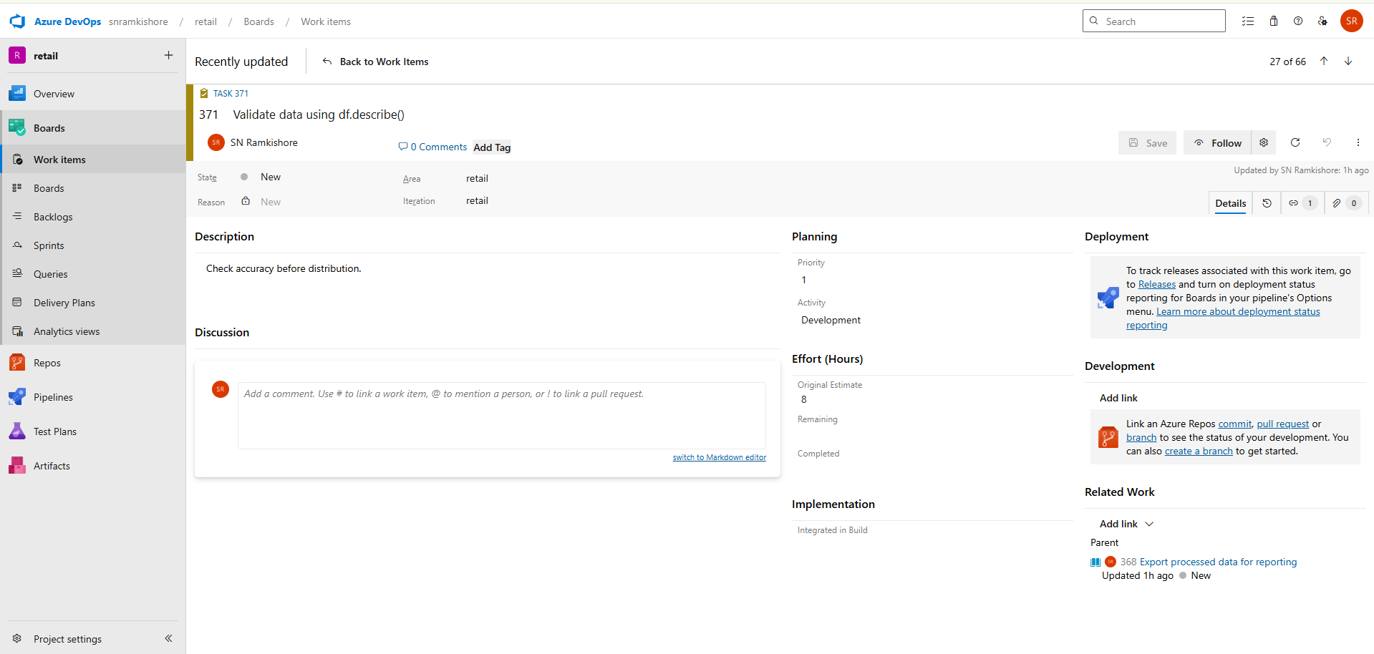

**Feature 4 – ETL Pipeline in Azure Databricks (Simulated in Colab)**

**Goal:**  
Build a pipeline that merges and transforms data to simulate Databricks ETL workflows.

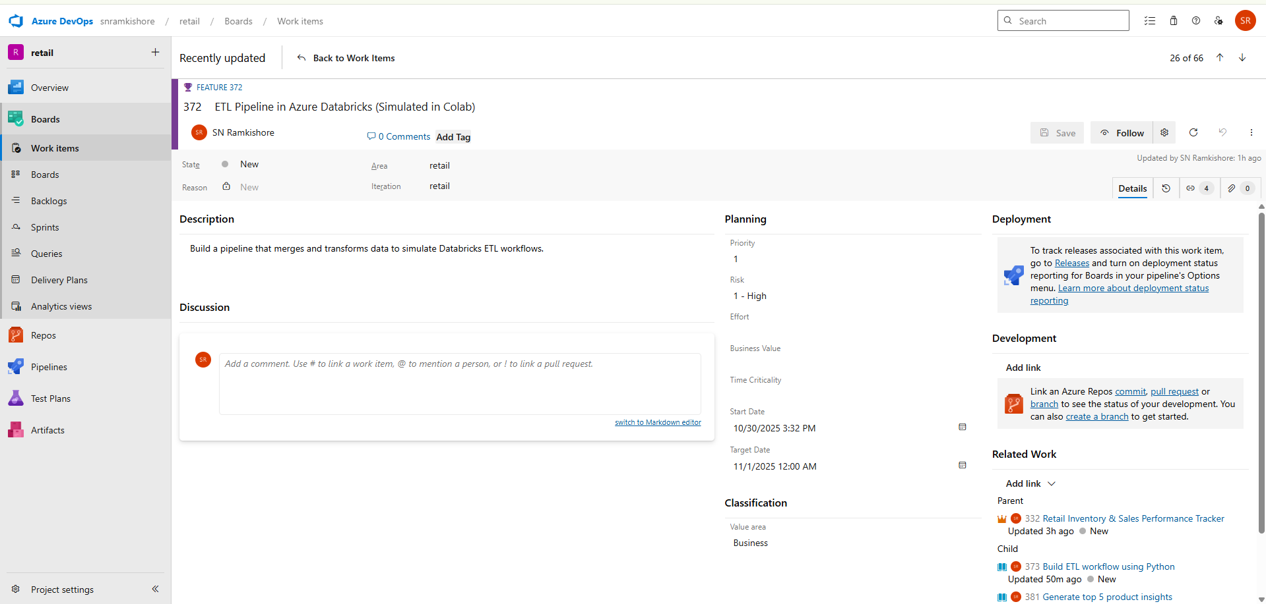

**User Story 1: Build ETL workflow using Python**

**Description:**  
As a data engineer, I want to automate the ETL pipeline to merge, transform, and update retail data.

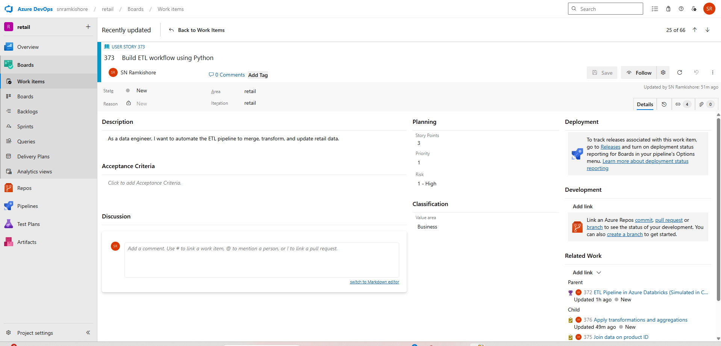

**Tasks:**

1. **Load cleaned sales and inventory data** – Read files into Pandas DataFrames.

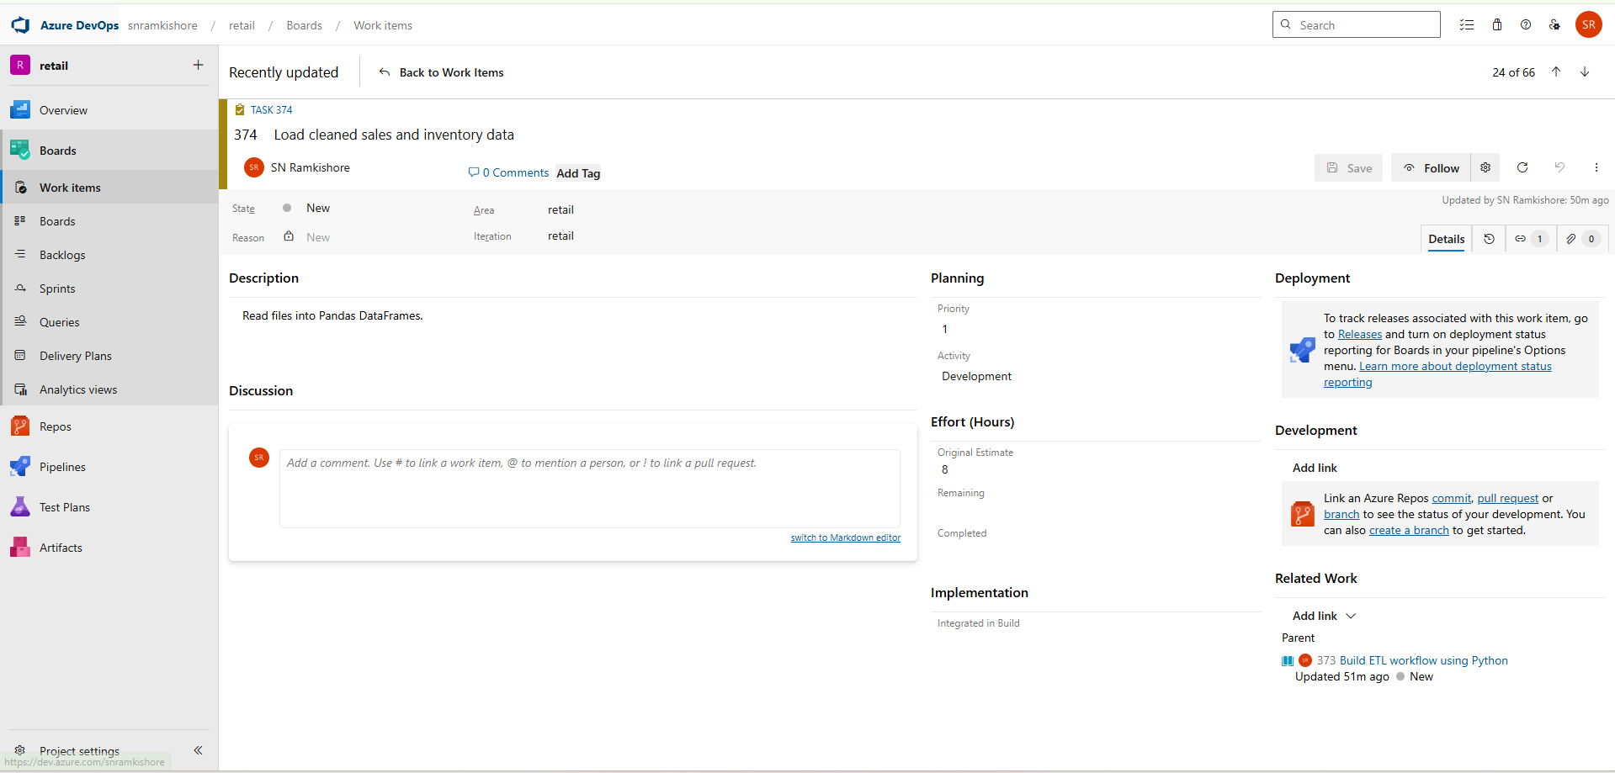

1. **Join data on product ID** – Merge datasets using pd.merge().

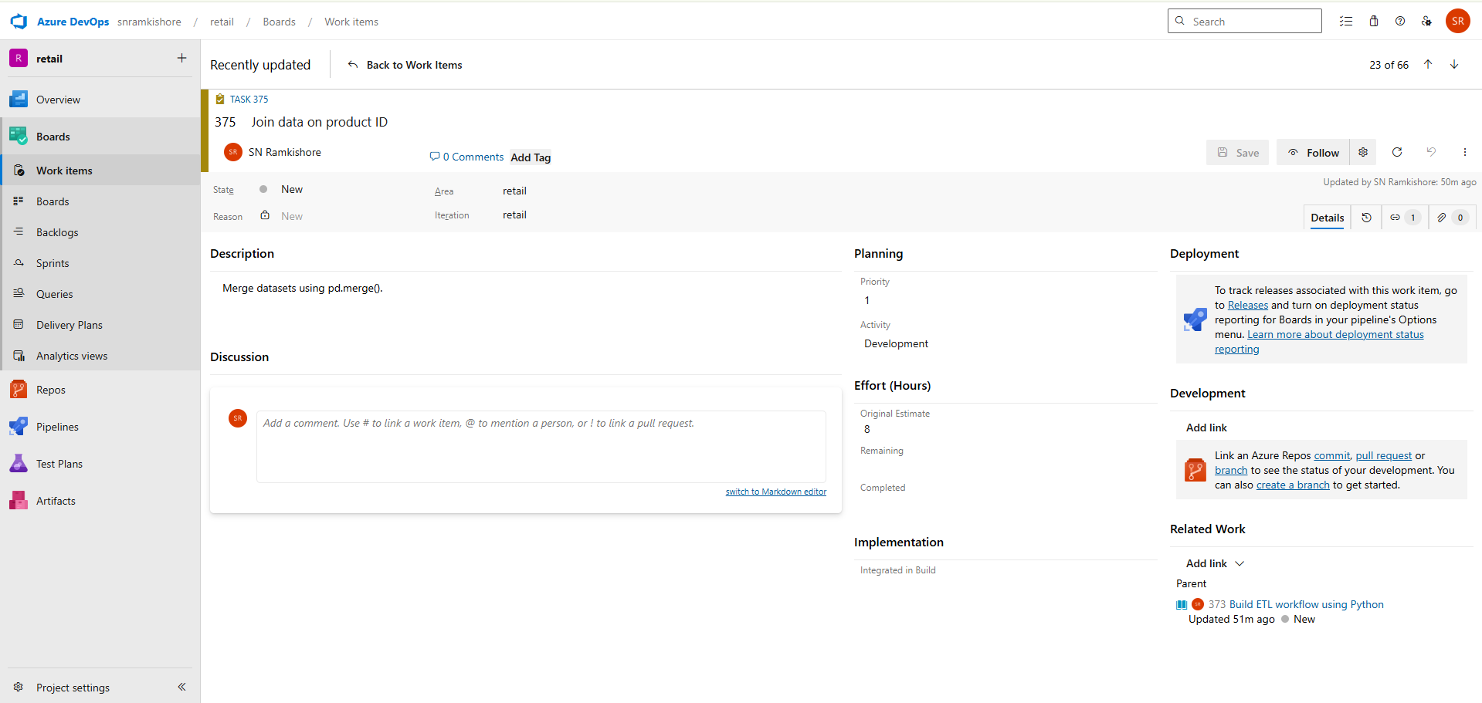

1. **Apply transformations and aggregations** – Add computed columns like total sales.

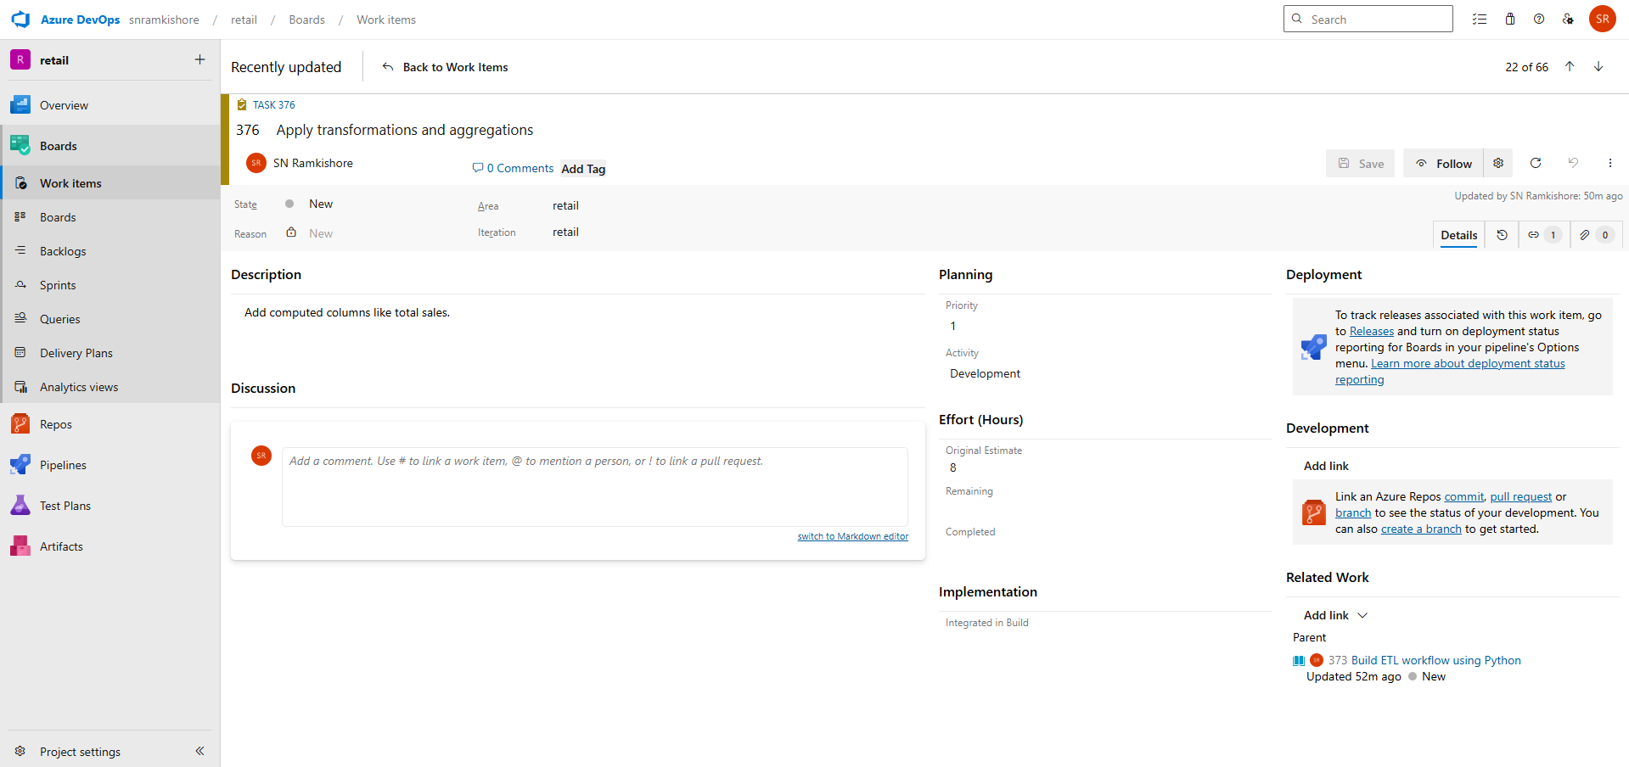

**User Story 2: Merge datasets for reporting**

**Description:**  
As an analyst, I want to combine datasets to generate unified sales and inventory reports.

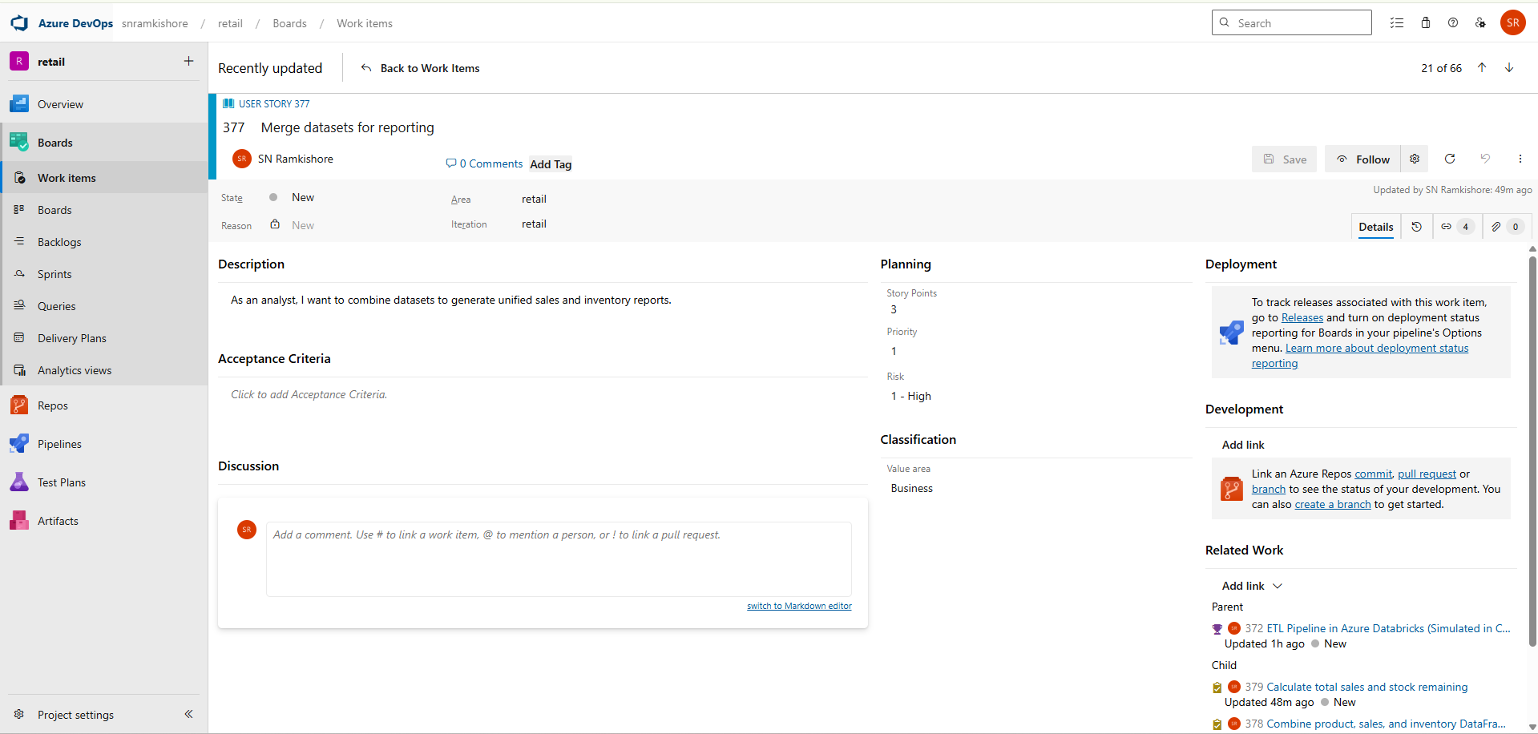

**Tasks:**

1. **Combine product, sales, and inventory DataFrames** – Use merge operations.

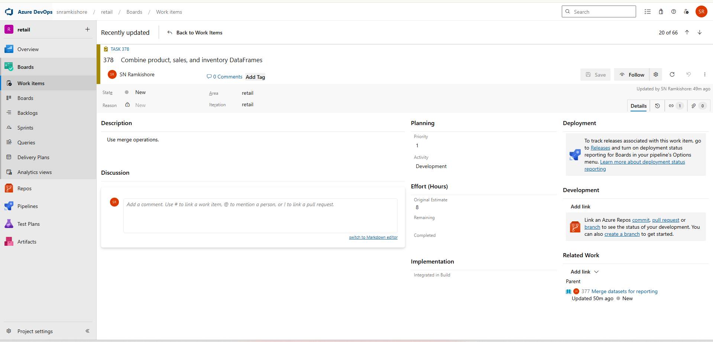

1. **Calculate total sales and stock remaining** – Add derived columns.

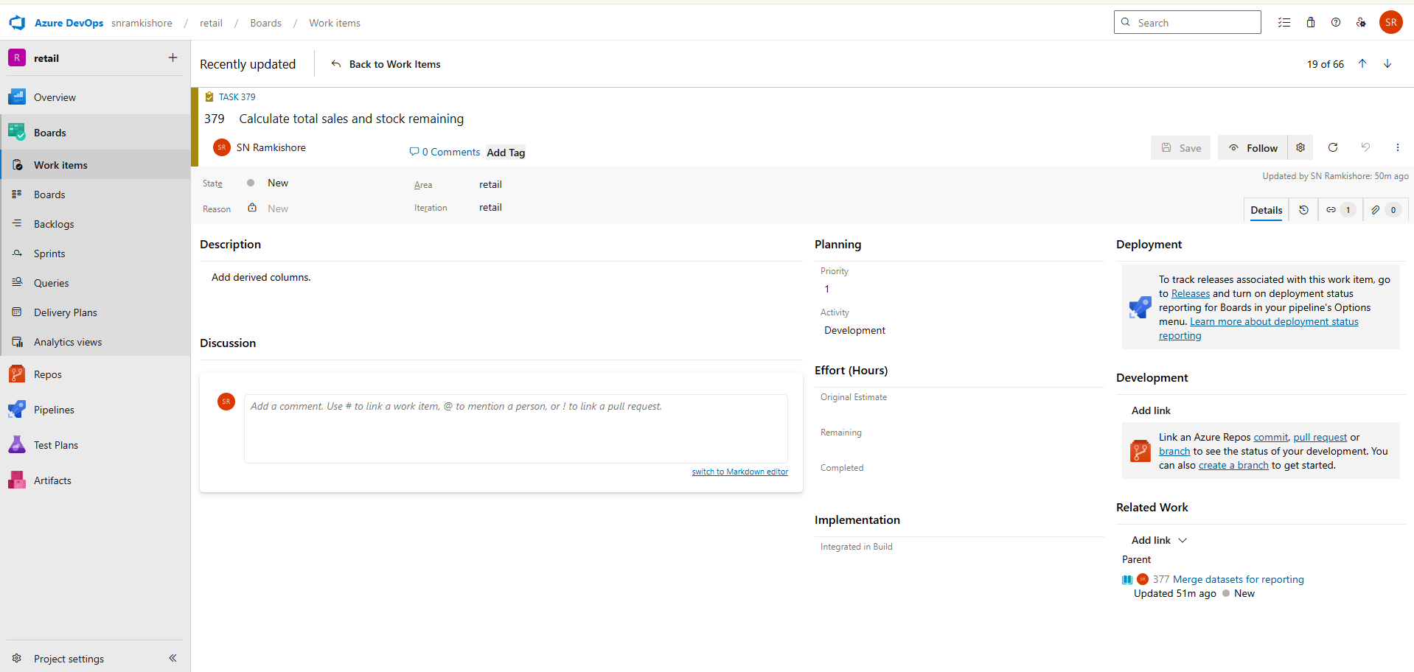

1. **Save merged dataset to Parquet** – Output results in efficient format.

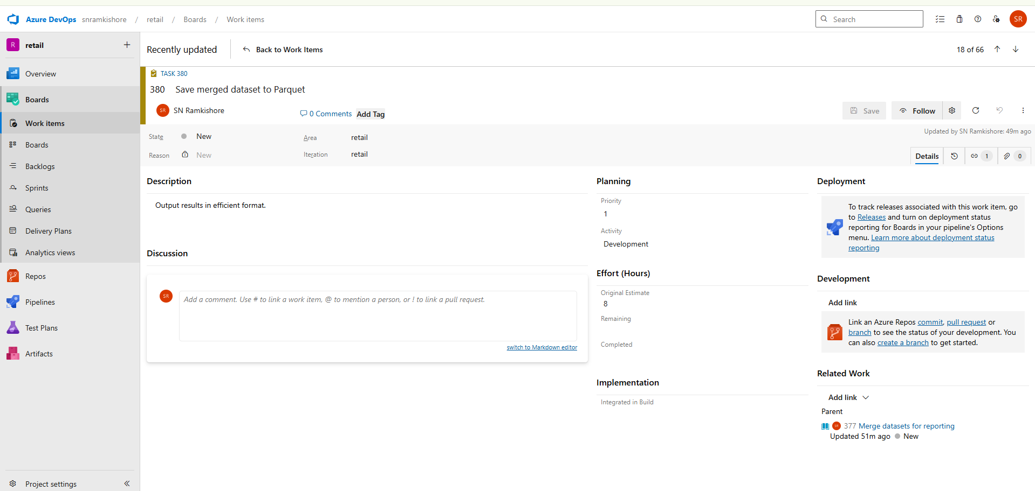

**User Story 3: Generate top 5 product insights**

**Description:**  
As a business user, I want to identify the top 5 best-selling products for executive reporting.

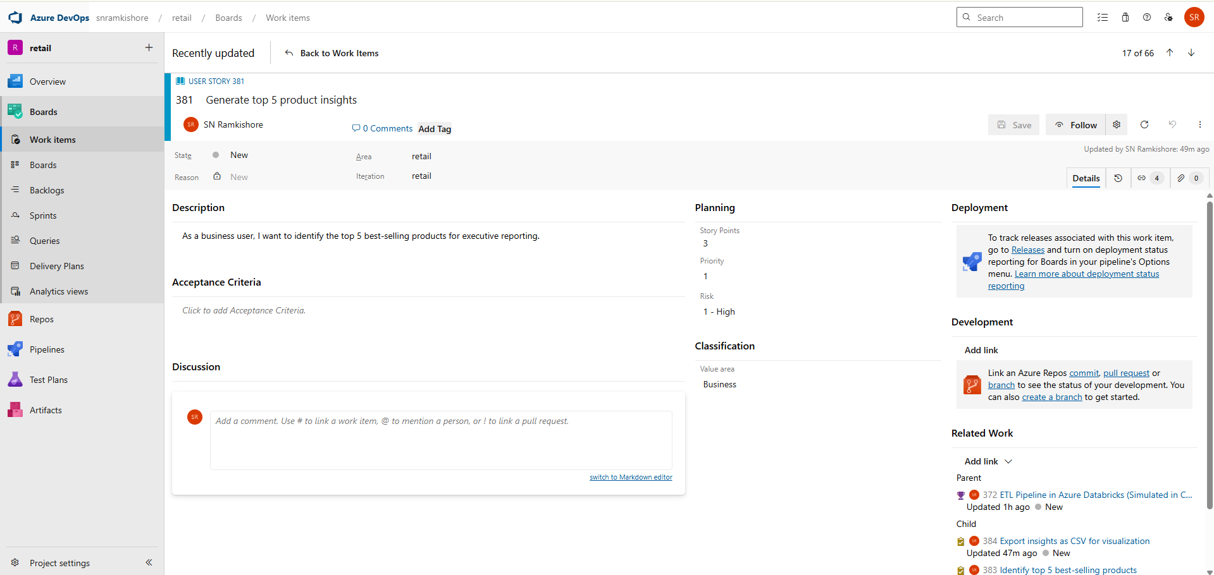

**Tasks:**

1. **Run SQL-like queries using Pandas or PySpark** – Use filtering and sorting functions.

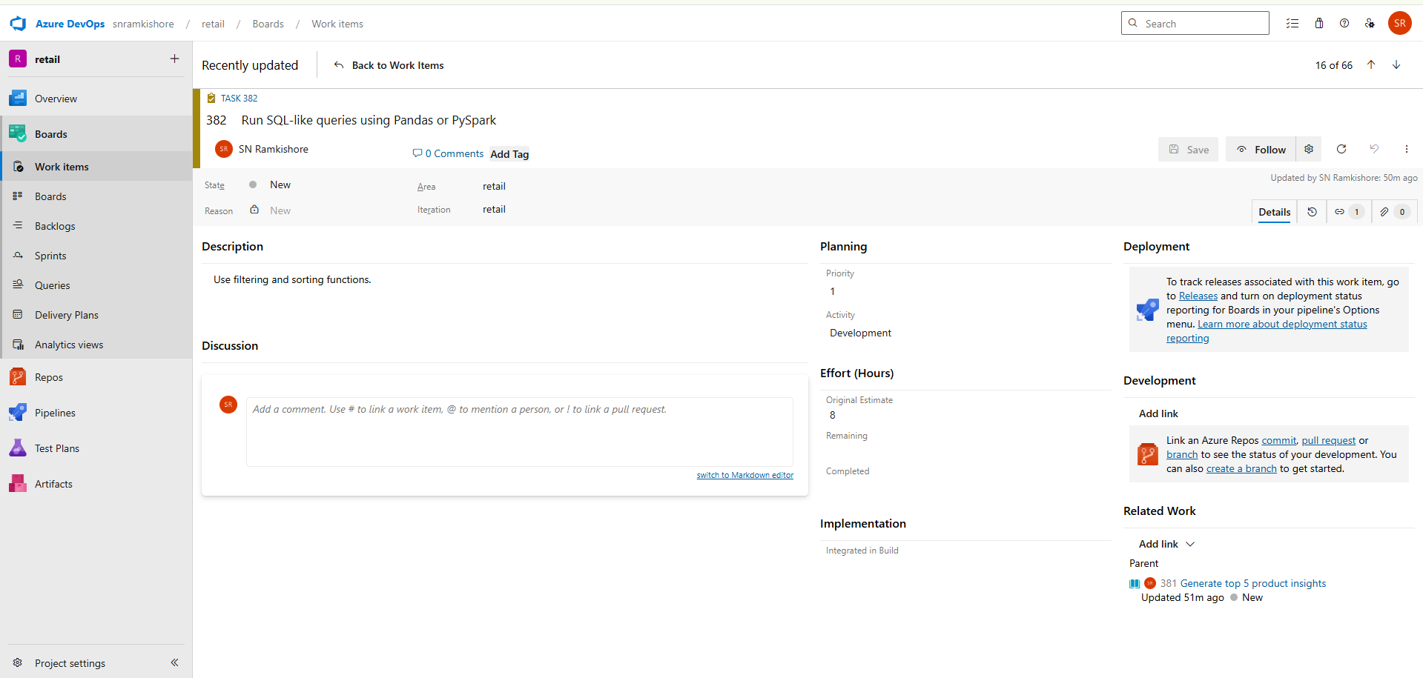

1. **Identify top 5 best-selling products** – Sort by sales volume or revenue.

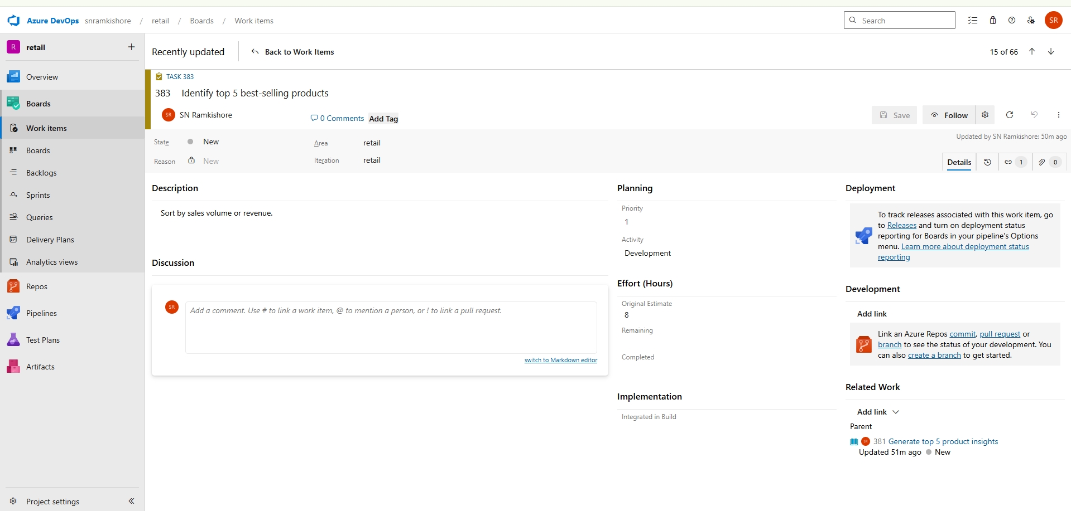

1. **Export insights as CSV for visualization** – Save for dashboard input.

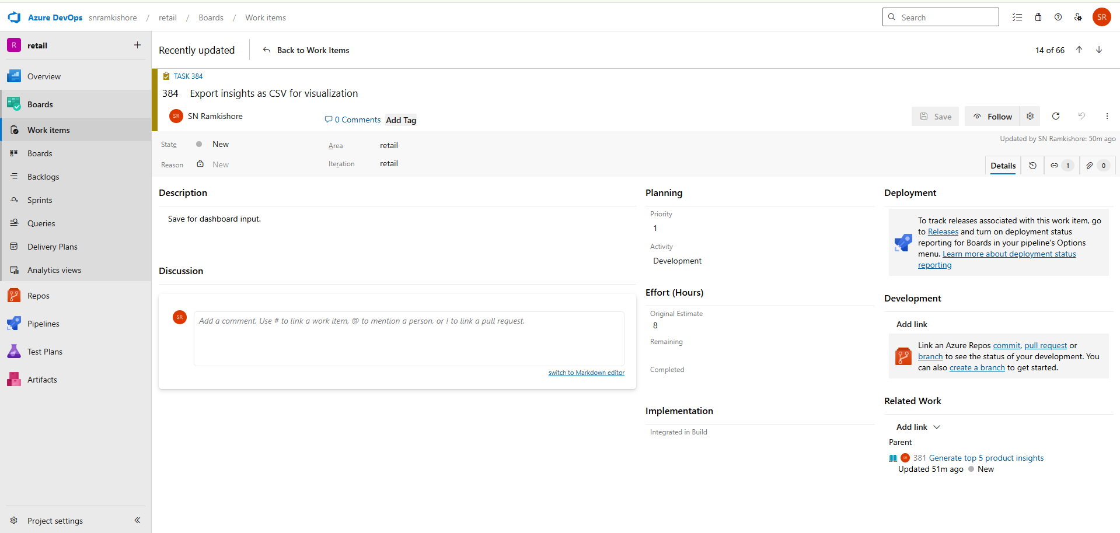

**Feature 5 – Project Automation & Tracking in Azure DevOps**

**Goal:**  
Automate and monitor all project work efficiently using DevOps tools.

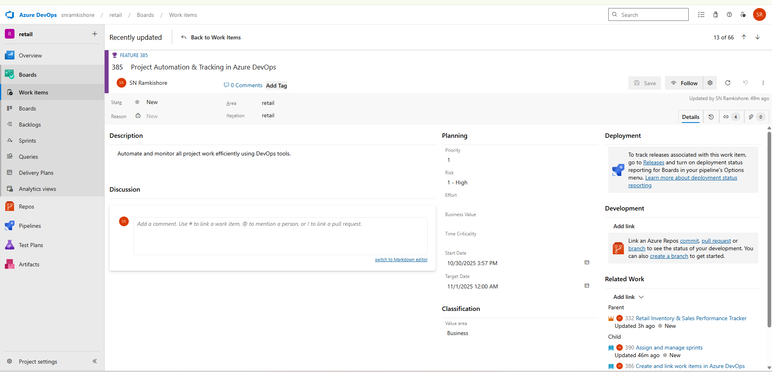

**User Story 1: Create and link work items in Azure DevOps**

**Description:**  
As a project manager, I want to organize all work items under a single Epic for better traceability.

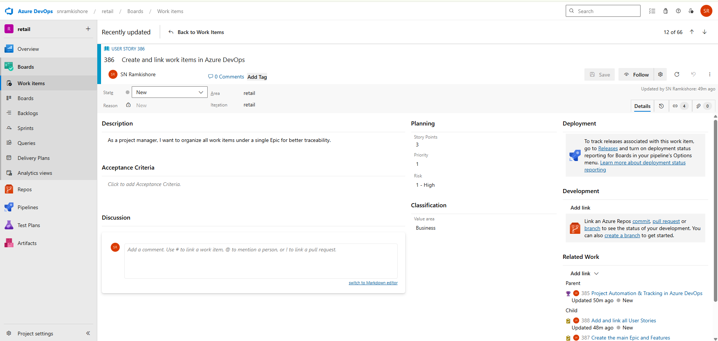

**Tasks:**

1. **Create the main Epic and Features** – Define overall project structure.

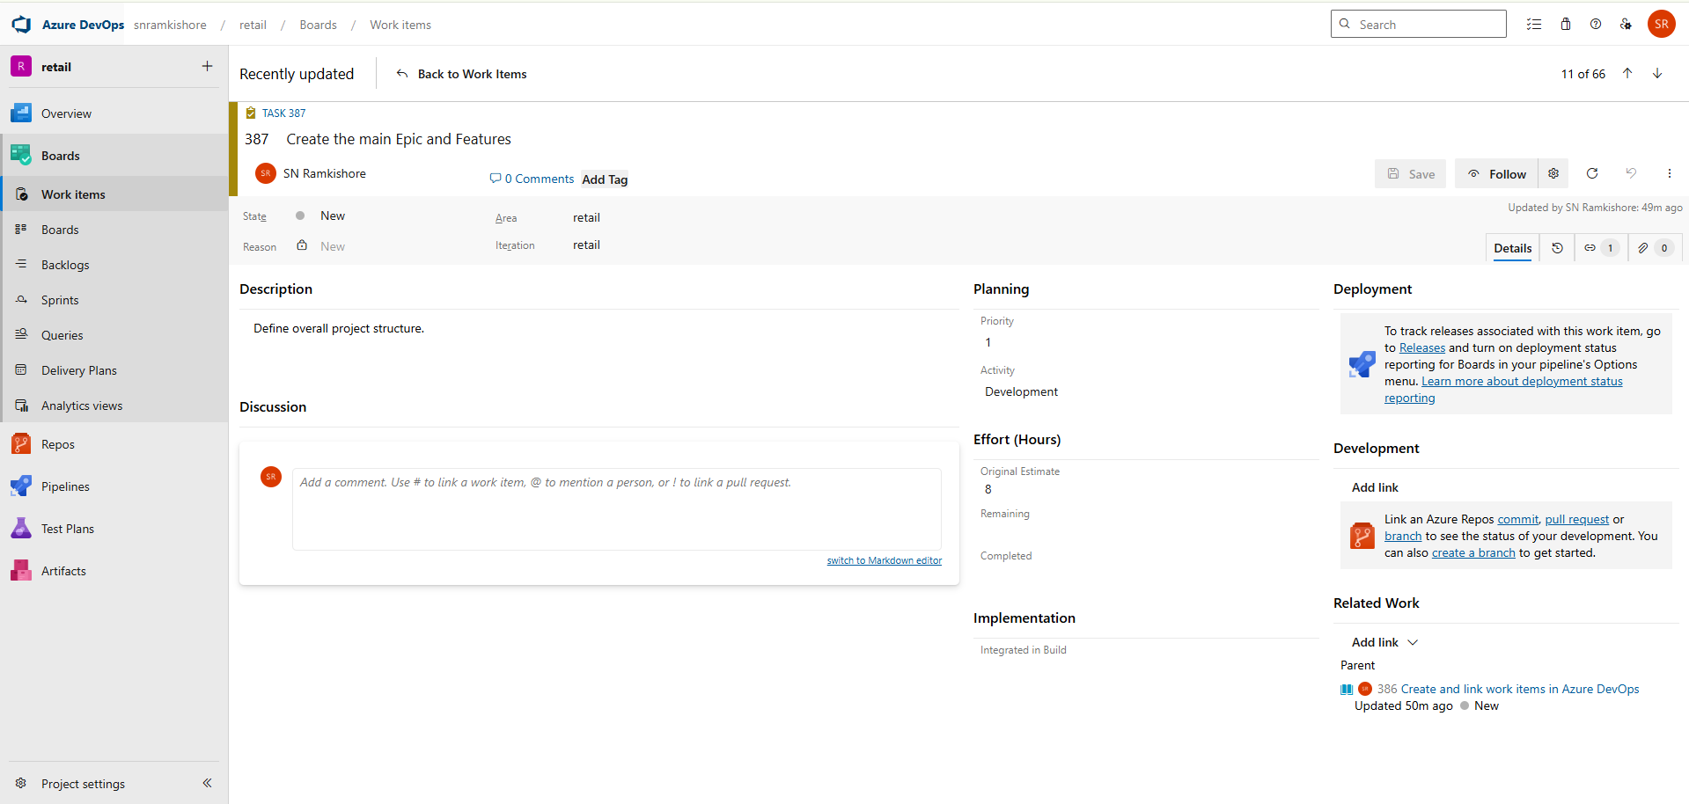

1. **Add and link all User Stories** – Ensure hierarchy is consistent.

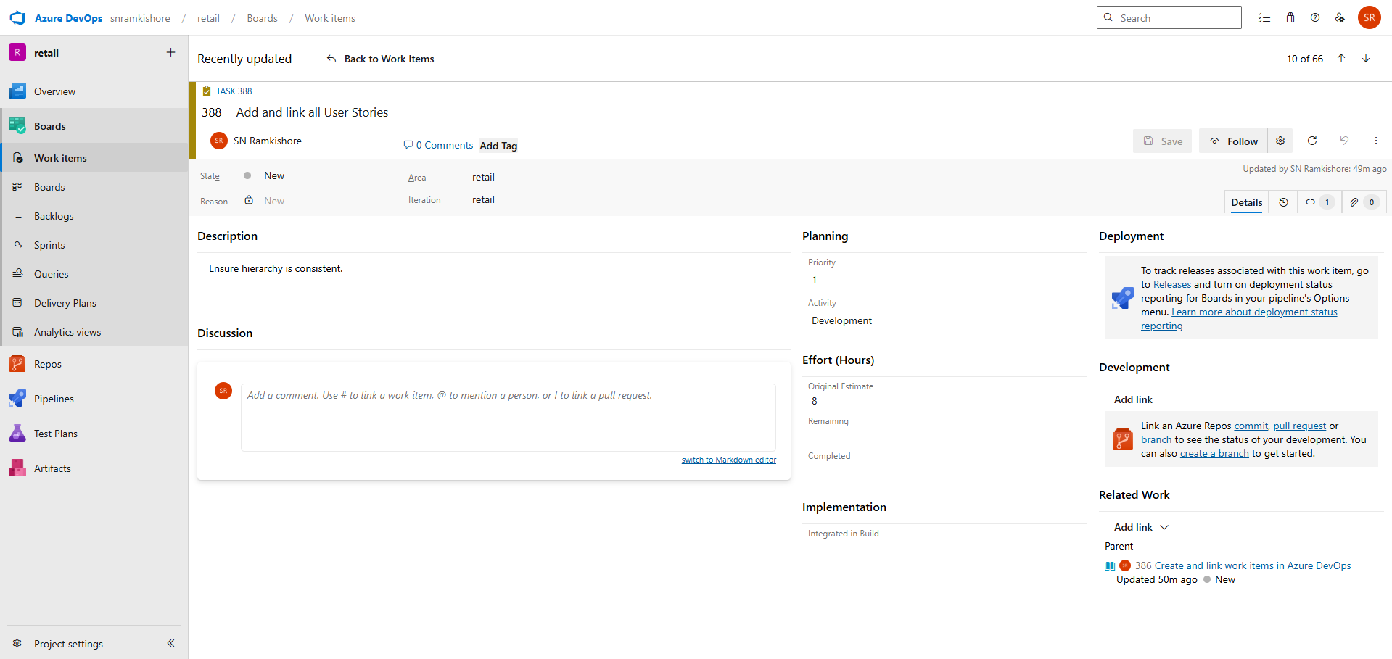

1. **Verify connections between all work items** – Maintain clean relationships.

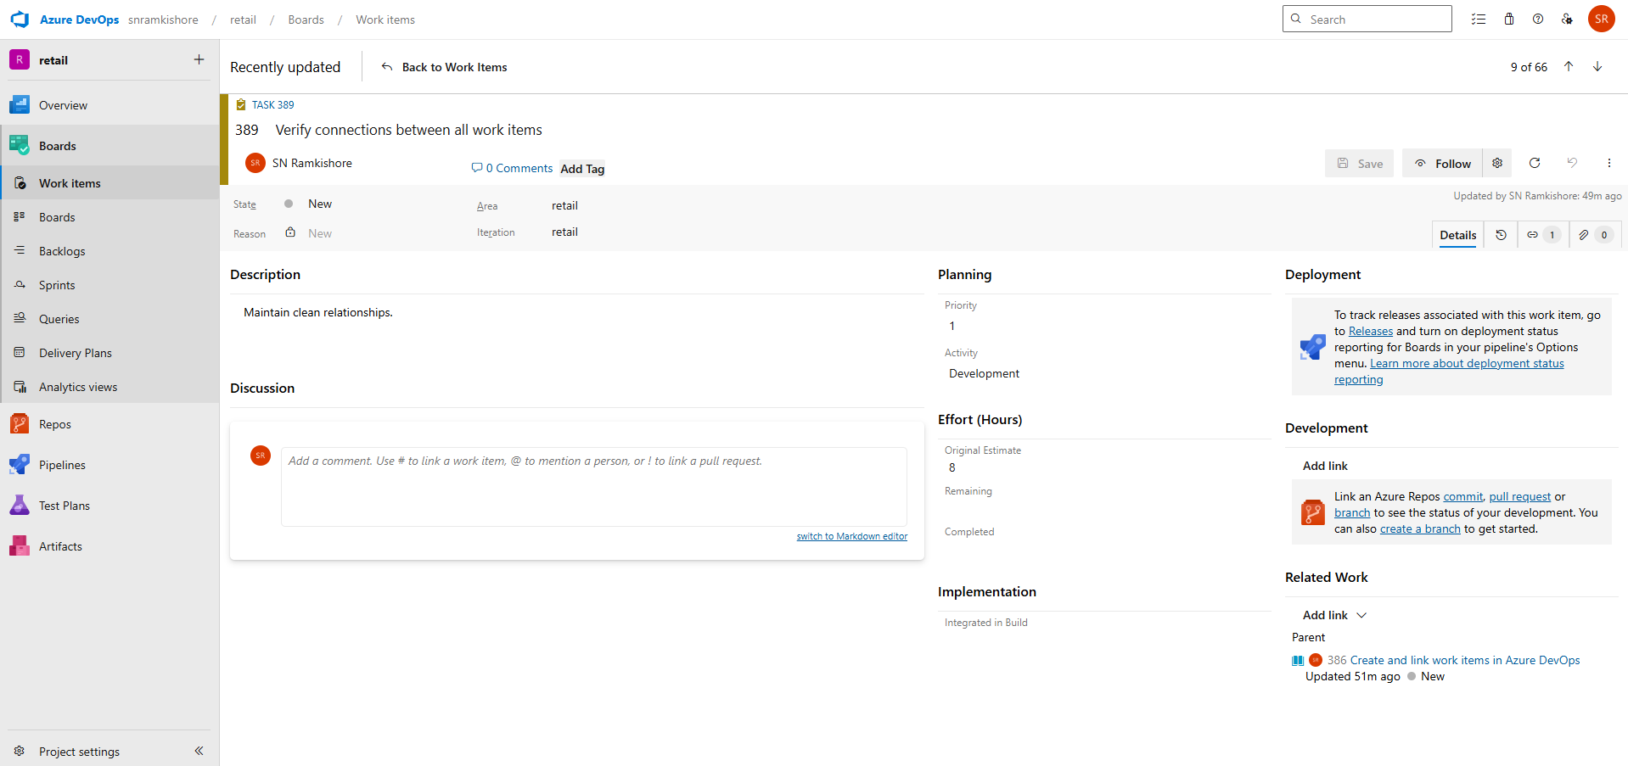

**User Story 2: Assign and manage sprints**

**Description:**  
As a scrum master, I want to assign tasks to sprints and members to ensure progress tracking.

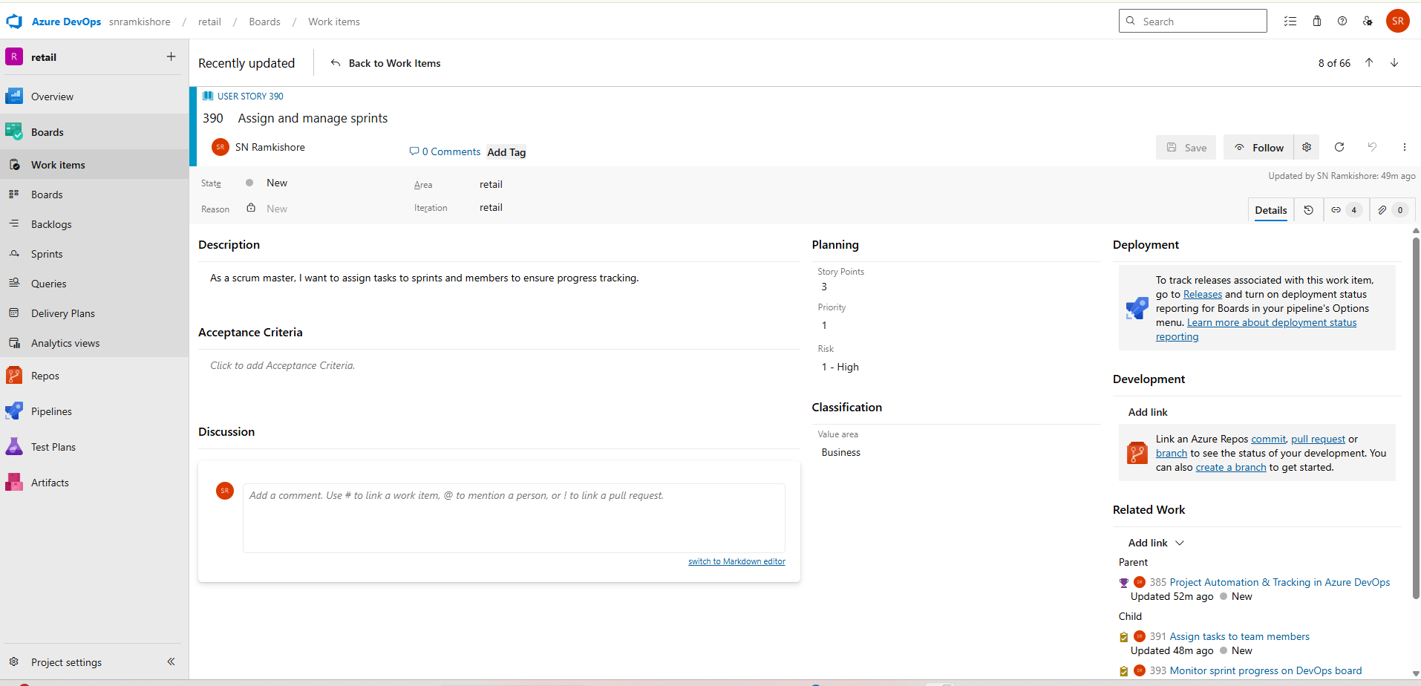

**Tasks:**

1. **Assign tasks to team members** – Allocate responsibilities clearly.

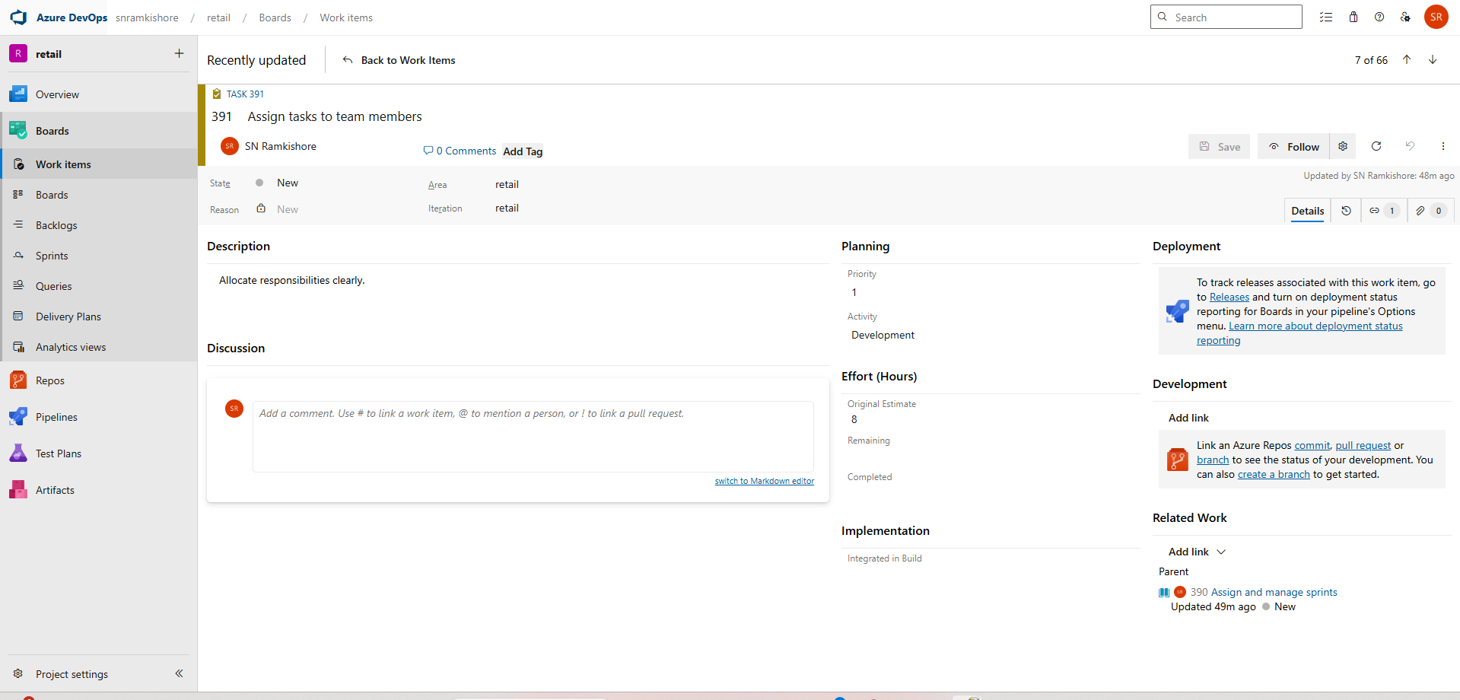

1. **Set iteration paths and sprint timelines** – Define sprint durations.

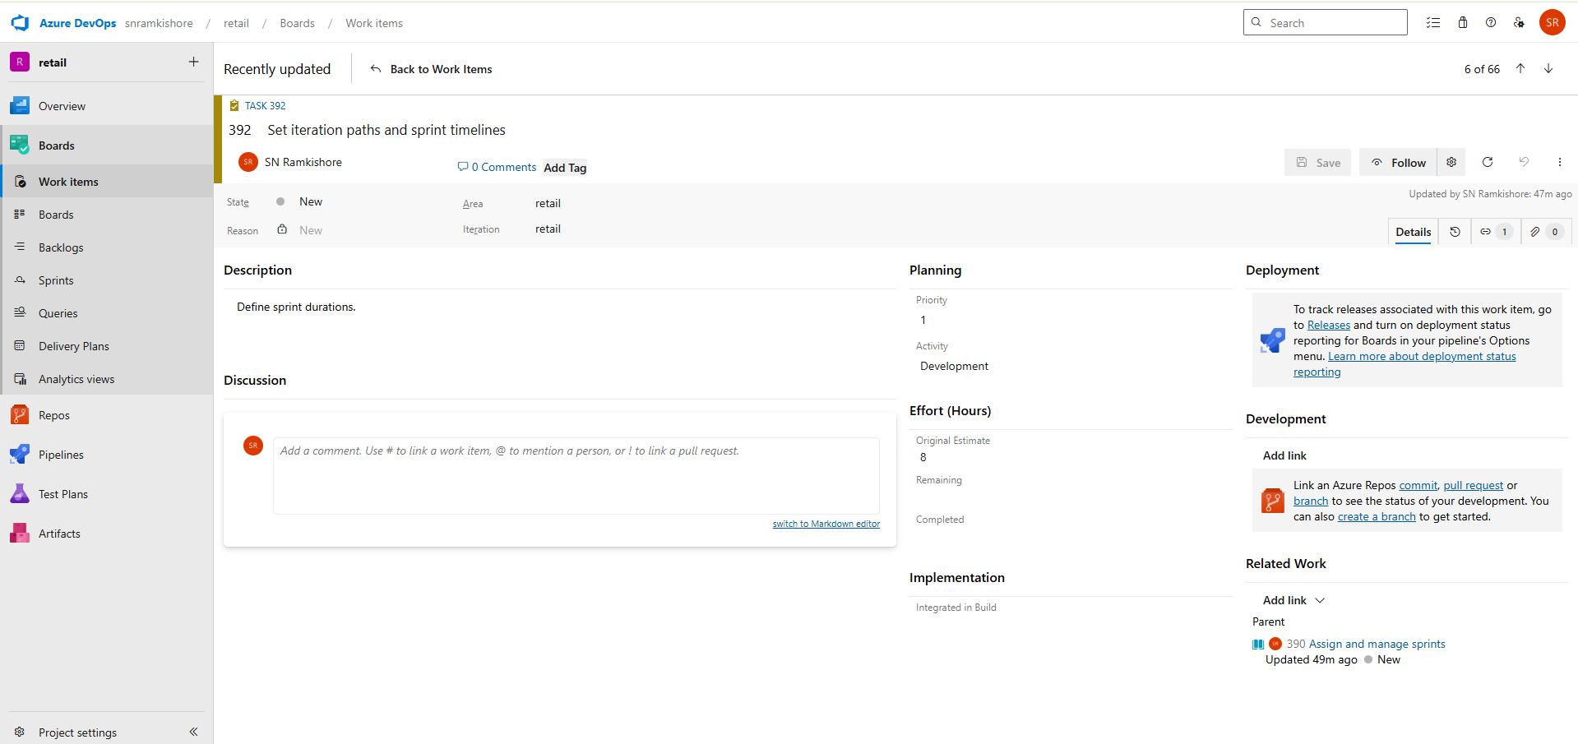

1. **Monitor sprint progress on DevOps board** – Track active work items.

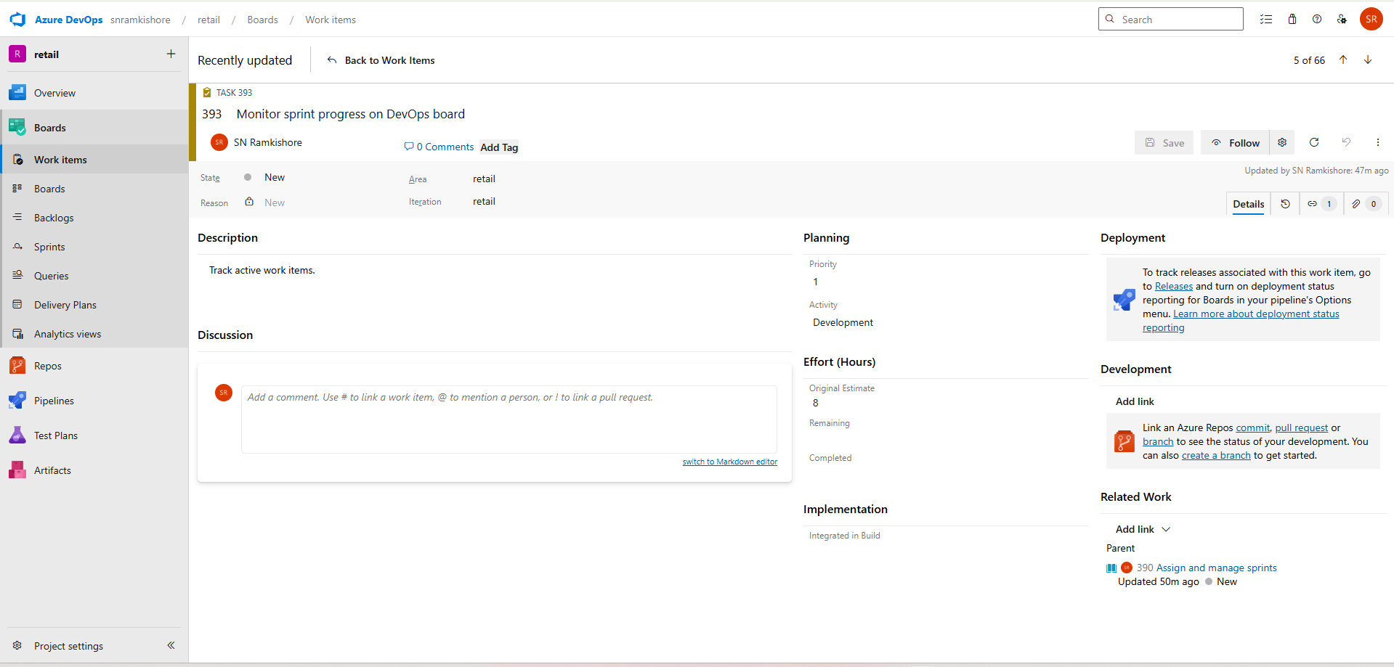

**User Story 3: Update progress and close items**

**Description:**  
As a team member, I want to update task statuses and close completed items for project visibility.

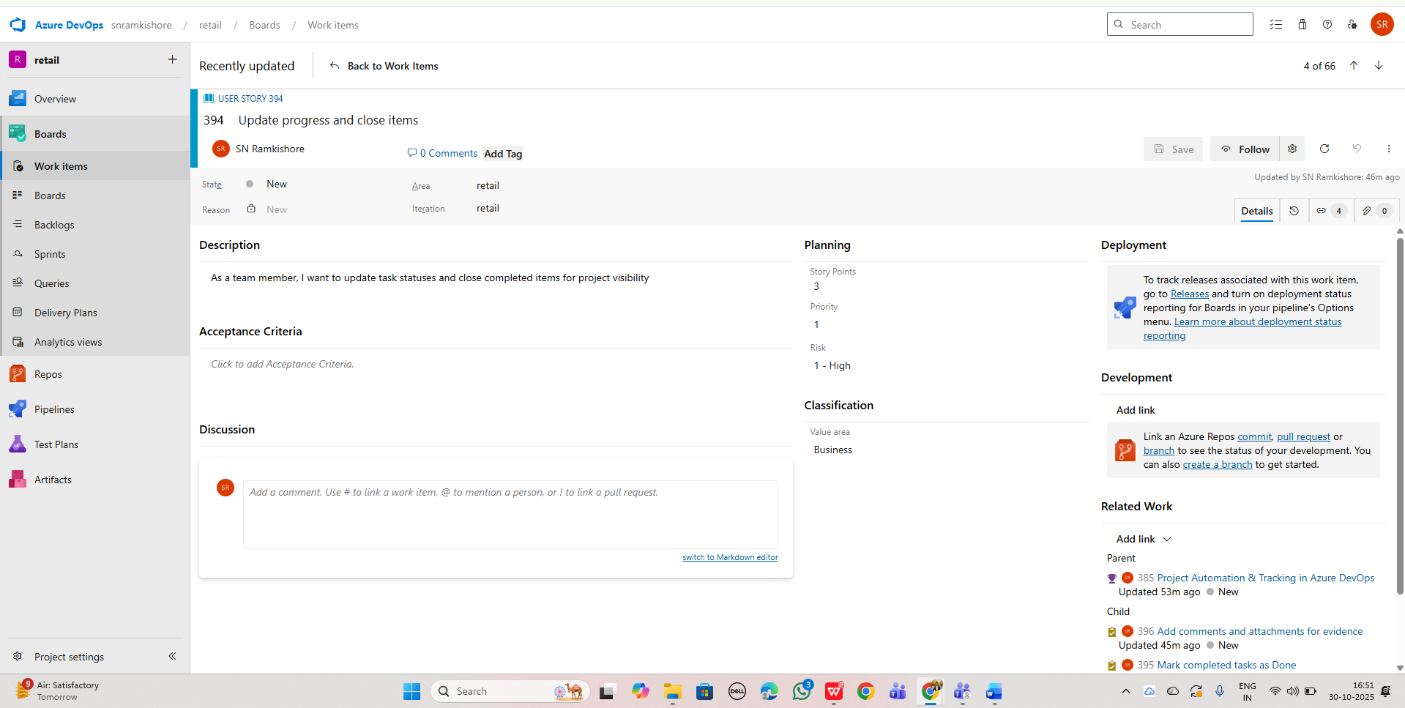

**Tasks:**

1. **Mark completed tasks as Done** – Update item status.

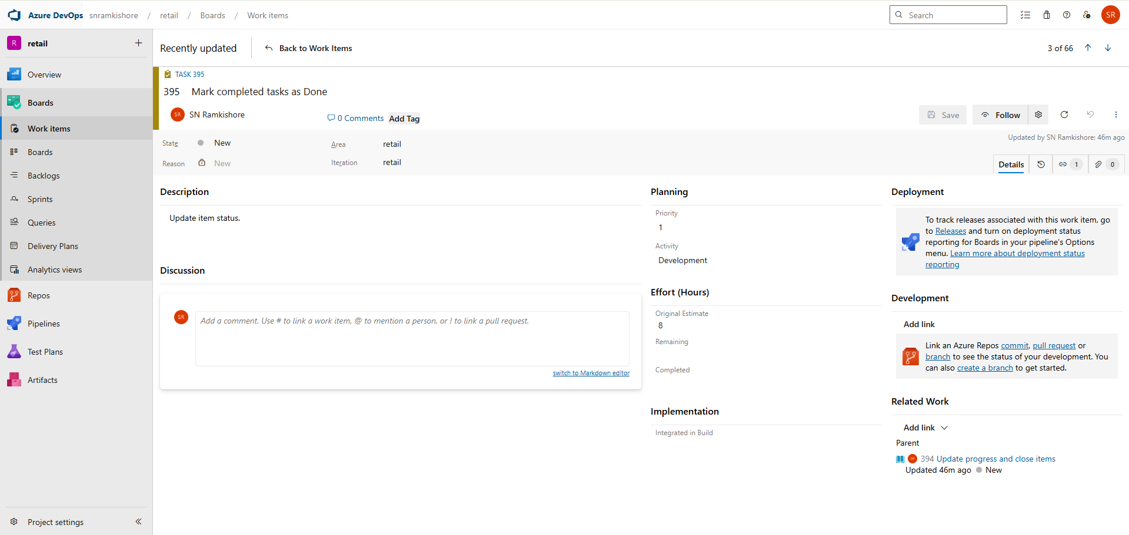

1. **Add comments and attachments for evidence** – Provide documentation.

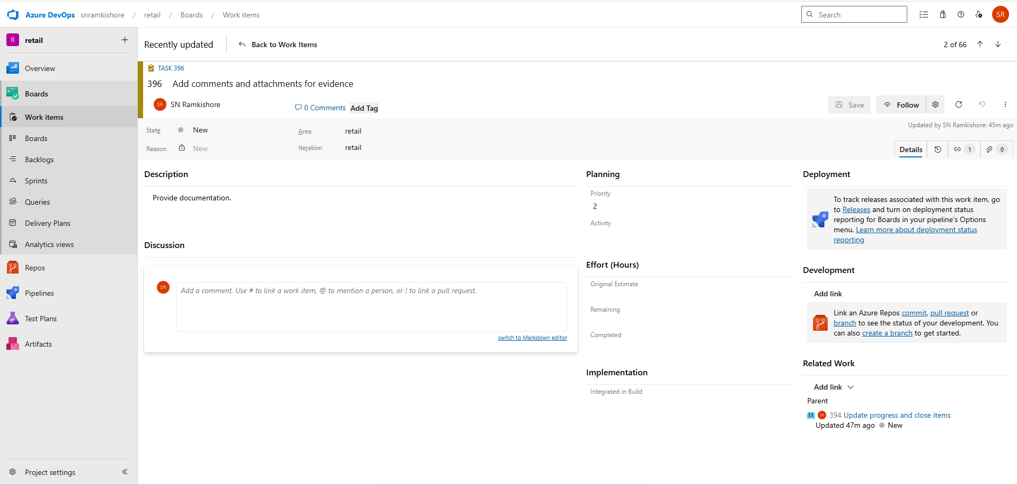

1. **Review and finalize all work items** – Ensure readiness for sprint closure.

